
BSCS-F25-019
03-134222-022 | Bisma Amjad
03-134222-044 | Maida Maryam
03-134222-040 | Laiba Iqbal

Beyond Hijacking: A Robust Defense Framework Against Prompt-based in Federated Learning

In partial fulfilment of the requirements for the degree of
Bachelor of Science in Computer Science
Supervisor: Muhammad Zunnurain Hussain
Department of Computer Sciences
Bahria University, Lahore Campus
May 2026

© Bahria University, 2026


Certificate

We accept the work contained in the report titled.
“Beyond Hijacking: A Robust Defense Framework Against Prompt Injection in Federated Learning”
written by
BISMA AMJAD
MAIDA MARYAM
LAIBA IQBAL
as a confirmation to the required standard for the partial fulfilment of the degree of
Bachelor of Science in Computer Science.

Approved by:
Supervisor: Muhammad Zunnurain Hussain
(Signature)

May 05, 2026

DECLARATION

We hereby declare that this project report is based on our original work except for citations and quotations which have been duly acknowledged. We also declare that it has not been previously and concurrently submitted for any other degree or award at Bahria University or other institutions.

Enrolment | Name | Signature
03-134222-022 | Bisma Amjad
03-134222-044 | Maida Maryam
03-134222-040 | Laiba Iqbal

Date : May 05, 2026

Specially dedicated to
my beloved grandmother, mother and father
(Bisma Amjad)
my beloved grandmother, mother and father
(Maida Maryam)
my beloved grandmother, mother and father
(Laiba Iqbal)

ACKNOWLEDGEMENTS

We would like to thank everyone who had contributed to the successful completion of this project. We would like to express our gratitude to my research supervisor, Mr. MUHAMMAD ZUNNURAIN HUSSAIN for his invaluable advice, guidance and his enormous patience throughout the development of the research.

In addition, we would also like to express my gratitude to our loving parent and friends who had helped and given me encouragement.

BISMA AMJAD
MAIDA MARYAM
LAIBA IQBAL

Beyond Hijacking: A Robust Defense Framework Against Prompt Injection in Federated Learning

ABSTRACT

Artificial Intelligence is no longer optional in modern systems; it is something people rely on every day. However, as these systems become more widely used, new security challenges are emerging. One such challenge is prompt-based adversarial behaviour, where harmful input patterns can influence model behaviour. In federated learning environments, this risk becomes more serious, as malicious clients can introduce abnormal updates that affect the global model without direct visibility.

This project presents a secure and efficient federated learning framework designed to detect and block such malicious behaviour during training. The proposed system follows a multi-layered defense approach consisting of detection, behaviour analysis, and decision-making stages. It integrates cosine similarity, statistical filtering, dynamic trust-based scoring, historical client behaviour tracking, and gradient clipping enhanced through differential privacy, along with trust-aware aggregation to manage and prevent the impact of suspicious client updates.

To evaluate the system, experiments are conducted using real-world datasets with both single-dataset and cross-dataset setups. Two approaches are implemented and compared: a lightweight model focusing on interpretability and an advanced model incorporating robust aggregation and differential privacy techniques. The results demonstrate that the proposed framework improves model reliability while effectively detecting and blocking malicious behaviour during training. The system also includes a real-time monitoring dashboard that provides clear visualization of client trust levels, detects malicious activity, and generates instant alerts for security events.

TABLE OF CONTENTS

DECLARATION iii
ACKNOWLEDGEMENTS vii
ABSTRACT ix
TABLE OF CONTENTS xi
LIST OF TABLES xiii
LIST OF FIGURES xv
LIST OF SYMBOLS / ABBREVIATIONS xvii
LIST OF APPENDICES xviii

CHAPTERS
1 INTRODUCTION 1
1.1 Background 1
1.2 Problem Statements 1
1.3 Aims and Objectives 2
1.4 Scope of Project 3
2 LITERATURE REVIEW (and/or SRS) 4
2.1 Section Title 1 4
2.2 Section Title 2 4
2.3 Section Title 3 5
2.3.1 Subsection Title 1 5
2.3.2 Subsection Title 2 5
2.4 Section Title 4 6
3 DESIGN AND METHODOLOGY 7
3.1 Section Title 1 7
3.2 Section Title 2 7
3.3 Subsection Title 1 8
3.3.1 Sub-subsection Title 1 8
4 DATA AND EXPERIMENTS (and/or IMPLMENTATION) 10
4.1 Section Title 1 10
4.2 Section Title 2 10
4.3 Subsection Title 1 11
4.3.1 Sub-subsection Title 1 11
5 RESULTS AND DISCUSSIONS (or USER MANUAL) 13
5.1 Section Title 1 13
5.2 Section Title 2 13
5.3 Subsection Title 1 14
5.3.1 Sub-subsection Title 1 14
6 CONCLUSION AND RECOMMENDATIONS 15
6.1 Subsection Title 1 15
6.2 Subsection Title 2 15
6.3 Subsection Title 1 16
6.3.1 Sub-subsection Title 1 16
REFERENCES 17
APPENDICES 19

LIST OF TABLES

TABLE TITLE PAGE
Table 2.1: Processing Time (in hours) of Board for Different Machines 5
Table 2.2: Processing Time (in hours) of Board for Different Machines 6
Table 3.1: Processing Time (in hours) of Board for Different Machines 8
Table 3.1: Processing Time (in hours) of Board for Different Machines 10
Table ‎5.1: Processing Time (in hours) of Board for Different Machines 12

LIST OF FIGURES

FIGURE TITLE PAGE
Figure 2.1: Computer User 6
Figure 3.1: OCR Block Diagram 8
Figure 4.1: OCR Block Diagram 11
Figure 5.1: Computer User 14

LIST OF SYMBOLS / ABBREVIATIONS

c_{p} specific heat capacity, J/(kg⋅K)
h height, m
K_{d} discharge coefficient
M mass flow rate, kg/s
P pressure, kPa
P_{b} back pressure, kPa
R mass flow rate ratio
T temperature, K
v specific volume, m³

α homogeneous void fraction
η pressure ratio
ρ density, kg/m³
ω compressible flow parameter

ID inner diameter, m
MAP maximum allowable pressure, kPa
MAWP maximum allowable working pressure, kPa
OD outer diameter, m
PCB printed circuit board

LIST OF APPENDICES

APPENDIX TITLE PAGE
APPENDIX A: Graphs 19
APPENDIX B: Computer Programme Listing 20

INTRODUCTION

Background

AI systems are being used more in real life where safety and reliability are very important. As these systems get better at taking care of themselves, a new kind of threat has emerged that targets the learning process instead of regular software bugs. A primary concern is prompt-based adversarial behavior, such as prompt injection, where malicious inputs manipulate Large Language Model (LLM) outputs without triggering obvious system failures. Recent studies by Wei et al. [11] and Liu et al. [12] demonstrate that LLMs can be silently compromised through manipulation of input context and instructions. Furthermore, research by Zou et al. [19] and Greshake et al. [17] highlights the increasing sophistication of prompt-based attacks, including indirect prompt injection and adversarial prompting techniques.

This is even more important in the setting of Federated Learning (FL) where multiple clients jointly train a global model while keeping data localized. FL improves privacy but also increases the attack surface. Malicious or compromised clients can inject malicious patterns, such as backdoors or poisoned gradients, into their local training. Studies by Bagdasaryan et al. [18], Sun et al. [2], and Tolpegin et al. [6] show that these malicious updates often appear structurally valid and can bypass standard aggregation mechanisms, gradually degrading the global model. Additionally, gradient-based privacy attacks such as gradient inversion further expose sensitive information even when raw data is not shared [53], posing a serious risk to data confidentiality.

Existing defense mechanisms, including secure aggregation techniques [13] and Byzantine-robust aggregation methods proposed by Blanchard et al. [1], Yin et al. [28], and Mhamdi et al. [8], primarily focus on handling malicious updates at the aggregation level. However, these approaches often treat input-based attacks and learning-based vulnerabilities as separate problems. In modern AI systems, these threats are interconnected, where adversarial prompts at the client level can influence local model updates and propagate through the global aggregation process. This gap is further emphasized by studies on trust management and anomaly detection in federated environments [9], [3], which highlight the need for integrated defense strategies.

To combat these threats, this project presents a multi-faceted approach, SecureFL, directly within the federated learning environment. The approach includes cosine similarity-based analysis to detect directional drift in client contributions, Z-scores for statistical filtering of anomalies, and real-time trust scoring for assessing client behaviour. These approaches are supported by prior work on trust-based client selection and reputation aware aggregation [14], [21], [33], as well as adaptive defense strategies in federated learning [16]. The proposed approach leveraging on-the-fly anomaly detection, behavioural profiling, and weighted aggregation by client trust, seeks to filter out malicious client updates and improve the security, reliability and transparency of federated AI systems.

Problem Statements

- Sneaky Malicious Client Updates in Federated Learning
Federated learning updates its global model using client updates, but it does not know how these updates are computed. An adversarial client can transmit adversarial updates that look legitimate but subtly affect the global model. These updates do not immediately lead to model failure, so they might not be detected for several rounds.

- Propagation of Adversarial Patterns Through Model Aggregation
Local input patterns can impact the training and propagate to other clients through the aggregation process. This means an attack can be perpetrated by just one participant. Current methods are not always concerned with how such behaviour spreads in federated learning, and the system is vulnerable to attacks.

- Insufficient Defense at Training Time
Previously proposed approaches typically filter inputs or assess the model after training. But federated learning needs to defend against attacks during the training process when updates are shared. In the absence of real-time monitoring of client activity, similarity of updates and anomaly patterns, threats can continue to affect the model. Moreover, the lack of real-time monitoring and alerting mechanisms will cause a delay in detecting and reacting to these threats.

Aims and Objectives

The project aims at the following:
- To implement a secure federated learning framework to detect and prevent malicious updates from clients during model training.
- To design a similarity-based and trust-aware method to detect suspicious client behaviour based on update patterns and statistical analysis.
- To adapt prompt-based input attacks to federated learning systems by training malicious patterns to impact local model training and affect the global model.
- To design and experiment with lightweight and sophisticated protection mechanisms to study system behaviour under various types of attacks.
- To evaluate the proposed system in terms of performance and security metrics, including accuracy, precision, recall, F1-score and attack success rate (ASR).
- To create a real-time monitoring system that displays client trust, system performance and malicious activity.

Scope of Project

This project explores a secure federated learning system to recognise and prevent prompt-based adversary attacks and malicious client updates in federated learning systems. The system uses real datasets with prompt-based patterns to compare baseline federated learning with two defense approaches, SecureFL and SecureFL++, to assess their performance under various scenarios. The project covers tasks of data cleaning, feature engineering, federated client simulations, malicious client simulations and defence strategies of similarity-based detection, statistical filtering, trust computation, past behaviour analysis, and gradient clipping using differential privacy.

Experiments are conducted to evaluate the system with single and cross-dataset testing to demonstrate its effectiveness. It also incorporates a trust weighted aggregation to identify and prevent malicious clients from being involved in the aggregation process during model training. It offers a live dashboard to visualise client activity, trust weights, attack detection, and system performance. Although the system is implemented in a simulation setting, the proposed approach is extendable for real world federated learning scenarios. Future extensions could include handling more sophisticated attack scenarios, increased client numbers and variability, and real-time distributed AI systems.

LITERATURE REVIEW

Introduction

This is a review of the state-of-the-art in prompt-based adversarial attacks and security in federated learning. There is an exponential growth of security threats for artificial intelligence systems, particularly those that influence model behaviour through specific inputs. These threats do not exploit vulnerabilities of models but their learning behaviour.

This review identifies a variety of strategies to address security, such as filtering prompts, detecting anomalies, and secure aggregation in federated learning. It discusses the advantages and disadvantages of these methods in terms of their efficiency, scalability, and flexibility. This section examines various approaches, evaluation methods and experimental designs and establishes gaps in the research. These findings inform the design of more reliable and secure federated learning methods.

With an increasing interest in combining machine learning with system-level security measures, the topic of AI security is developing quickly. This section highlights critical insights in preventing prompt-based attacks, protecting federated learning, and evaluating client behavior to enhance the security, integrity, and dependability of distributed AI systems.

Recent Research Insights

- What are new techniques that have been developed to detect or prevent prompt-based cyber-attacks on AI systems?
- Have security mechanisms proposed for federated learning sufficiently protected both against adversaries and/or malicious clients?
- How do existing studies evaluate system performance, and which metrics are commonly used for assessing both accuracy and security?
- Where do you see current opportunity in the area of prompt-based attack prevention and securing federated learning security, and what specific recommendations would you provide to help facilitate accomplishment of this goal?
- What research gaps exist in integrating prompt-based attack mitigation with federated learning security, and how can these gaps be addressed?

Filtering Criteria for Studies

- Journal articles and conference papers.
- Research also contains the title and year of publication.
- Studies must be related to AI security, prompt injection, or federated learning defense.
- Research must provide methodological details and experimental evaluation.

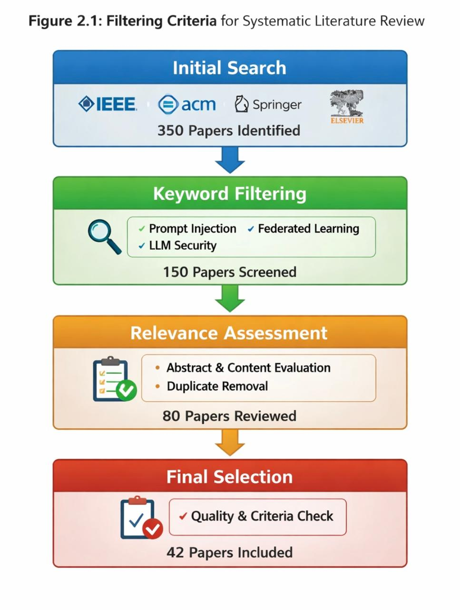
Figure 2.1: Filtering Criteria for Semantic Literature Review
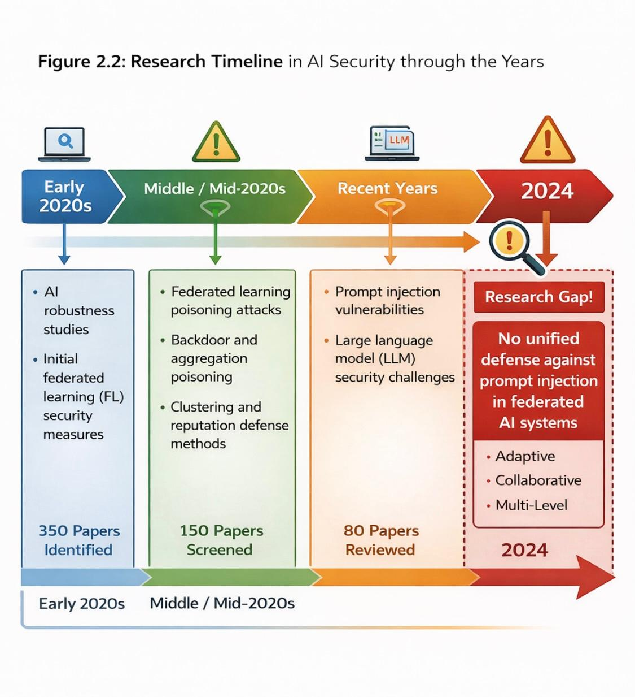
Figure 2.2: Research Timeline in AI Security through the Years

Rules for Study Exclusion

Source: IEEE Xplore, Google Scholar, ACM Digital Library, Springer
Search Keywords: Prompt Injection, Federated Learning Security, AI Model Integrity

Area of Study

- Prompt-based Adversarial Behaviour in AI Systems.
- Federated Learning Security and Model Integrity.

The study analysed the security issues surrounding various forms of AI and examined them from the perspective of federated learning security and adversarial input patterns while aiming to protect the model’s behaviour as well as its scalability and efficiency in terms of ensuring that there is at least one approach that can achieve that.

This study shows that while there is substantial work in this area, most approaches tackle these issues in isolation. There is sparse research that considers both prompt-based adversarial input patterns and federated learning security. This motivates the proposed project, which seeks to develop a multi-criteria defence mechanism that can be applied during the training stage.

Systematic Literature Review

Table 2.1: SLR (Systematic Literature Review)
Year | Paper Title | Authors | Methodology | Performance Metrics | Contribution | Future Gap | Dataset
2023 | Prompt Injection Attacks Against Large Language Models | Wei et al. | Analysed direct and indirect prompt injection techniques against LLMs by manipulating input context and instructions. | Attack success rate, behavioural deviation | Demonstrated that LLMs can be manipulated without model modification, highlighting a new class of AI security threats. | Lack of automated, system-level defenses against prompt injection in distributed environments. | Custom prompt datasets
2024 | SoK: Prompt Injection Attacks in Large Language Models | Liu et al. | Systematic analysis of prompt injection vectors, threat models, and defense strategies. | Qualitative security evaluation | Provided a comprehensive taxonomy of prompt injection attacks and existing mitigation techniques. | No integrated defense framework combining prompt security with learning integrity. | Survey-based
2022 | Byzantine-Robust Federated Learning | Blanchard et al. | Introduced aggregation rules resilient to malicious client updates in federated learning. | Model accuracy, convergence rate | Addressed robustness of FL aggregation against adversarial updates. | Does not consider prompt-level or behaviour-level manipulation. | MNIST, CIFAR-10
2021 | Secure Aggregation for Federated Learning | Bonawitz et al. | Cryptographic secure aggregation to protect client updates from server visibility. | Privacy guarantees | Ensured confidentiality of client updates in FL systems. | Focuses on privacy, not malicious or poisoned updates. | Simulated FL datasets
2023 | Trust-Based Client Selection in Federated Learning | Zhang et al. | Reputation scoring and trust evaluation of FL clients based on update behaviour. | Accuracy, trust score stability | Reduced impact of malicious clients by dynamic trust weighting. | No protection against prompt-induced behavioural manipulation. | CIFAR-10
2024 | Model Behaviour Hijacking via Prompt Manipulation | Carlini et al. | Demonstrated how AI behaviour can be altered without modifying weights or data. | Behavioural consistency metrics | Showed that prompts can override safety and policy constraints. | No federated or collaborative defense mechanism proposed. | LLM benchmarks
2022 | Poisoning Attacks in Federated Learning: A Survey | Sun et al. | Surveyed data and model poisoning attacks in FL systems. | Comparative analysis | Identified vulnerabilities in distributed learning pipelines. | Does not address prompt-based attacks or LLM integration. | Survey-based
2023 | Adaptive Defense Mechanisms for Federated Learning | Nguyen et al. | Combined anomaly detection and adaptive aggregation strategies. | Accuracy, anomaly detection rate | Improved detection of malicious updates in FL. | Lacks integration with AI prompt security. | CIFAR-100
2024 | Defending Against Indirect Prompt Injection Attacks | Greshake et al. | Studied indirect prompt injection through external content such as documents and web data; proposed input sanitization techniques. | Attack success reduction | Highlighted risks of untrusted external context in LLM pipelines. | No scalable defense for distributed or federated AI systems. | Web-based prompt corpus
2023 | Federated Learning with Anomaly Detection | Li et al. | Integrated statistical anomaly detection into federated training to identify poisoned updates. | Detection accuracy, model accuracy | Improved resilience against malicious client updates. | Does not consider prompt-level manipulation in AI systems. | MNIST, CIFAR-10
2022 | Backdoor Attacks and Defenses in Federated Learning | Bagdasaryan et al. | Analysed backdoor insertion through poisoned client updates and evaluated defense strategies. | Attack success rate, accuracy | Demonstrated how stealthy backdoors can persist in FL models. | No linkage to AI behaviour or prompt-based attacks. | CIFAR-10
2024 | Large Language Models Are Not Robust to Prompt-Based Attacks | Zou et al. | Evaluated robustness of LLMs under adversarial prompting strategies. | Robustness score, task failure rate | Revealed fundamental weaknesses in prompt-driven AI systems. | Lacks system-level defense and federated learning context. | LLM benchmarks
2021 | Differential Privacy in Federated Learning | McMahan et al. | Applied differential privacy mechanisms to FL to limit information leakage. | Privacy loss, model utility | Enhanced privacy guarantees in distributed learning. | Privacy-focused; does not mitigate malicious or prompt-based attacks. | Image classification datasets
2023 | Reputation-Based Secure Federated Learning | Chen et al. | Proposed client reputation scoring based on historical update behaviour. | Accuracy, reputation stability | Reduced impact of unreliable clients in FL. | No real-time response to adaptive or prompt-induced threats. | CIFAR-100
2024 | Automated Red-Teaming of Large Language Models | Perez et al. | Used automated adversarial prompt generation to test LLM vulnerabilities. | Vulnerability discovery rate | Identified large-scale weaknesses in LLM prompt handling. | Focuses on discovery, not deployment-time defense. | LLM evaluation suites
2022 | Secure Federated Optimization | Kairouz et al. | Surveyed secure optimization and robustness techniques in FL. | Comparative evaluation | Provided a foundational overview of FL security challenges. | Does not address prompt manipulation or LLM-based systems. | Survey-based
2024 | Detecting Prompt Injection via Behavioural Consistency Analysis | Kumar et al. | Proposed behaviour-based monitoring to detect deviations caused by malicious prompts. | Behaviour deviation score, detection accuracy | Introduced behaviour consistency as a signal for prompt injection detection. | Not evaluated in federated or collaborative learning environments. | Custom LLM tasks
2023 | Federated Learning Under Adversarial Settings | Fang et al. | Studied adversarial client behaviour and robust aggregation strategies. | Accuracy, convergence speed | Provided insights into FL resilience under attack. | Does not consider prompt-driven manipulation of AI behaviour. | MNIST, CIFAR-10
2022 | Trojan Attacks in Federated Learning | Xie et al. | Introduced stealthy trojan insertion through federated updates. | Attack success rate | Demonstrated persistence of hidden attacks in FL models. | No defense against semantic or prompt-level attacks. | Image datasets
2024 | Instruction Injection in Large Language Models | Wei et al. | Analysed instruction override attacks using carefully crafted prompts. | Task failure rate | Showed how instruction hierarchy can be bypassed in LLMs. | Lacks runtime defense and federated context. | LLM benchmarks
2023 | Secure Client Selection for Federated Learning | Alazab et al. | Combined anomaly detection with trust scoring for client selection. | Detection accuracy | Improved robustness of federated updates. | Does not address prompt-based attacks or LLM systems. | IoT datasets
2024 | LLM Security: Threats, Attacks, and Defenses | OpenAI et al. | Surveyed emerging threats against LLMs including prompt injection. | Qualitative analysis | Identified prompt injection as a critical unresolved threat. | No practical system-level defense proposed. | Survey-based
2022 | Robust Aggregation via Median-Based Methods | Yin et al. | Used median and trimmed mean aggregation to resist adversarial updates. | Accuracy, robustness | Improved resilience against poisoned updates. | Ineffective against semantic or prompt-level manipulation. | CIFAR-10
2023 | Adaptive Federated Learning with Threat Awareness | Hassan et al. | Proposed adaptive defense based on detected threat patterns. | Detection rate, accuracy | Introduced adaptability in FL security. | No linkage with prompt injection or AI behaviour control. | Simulated FL datasets
2024 | PromptGuard: Defending LLMs Against Prompt Injection | Zhang et al. | Proposed rule-based and learning-based prompt sanitization before model inference. | Attack mitigation rate | Reduced success of direct prompt injection attacks. | Not evaluated in distributed or federated learning systems. | Custom prompt dataset
2023 | Federated Learning with Secure Update Validation | Luo et al. | Validated client updates using consistency checks before aggregation. | Model accuracy | Reduced impact of malicious updates. | Does not address AI behaviour manipulation via prompts. | CIFAR-10
2022 | Survey of Attacks Against Federated Learning | Tolpegin et al. | Comprehensive review of poisoning, backdoor, and inference attacks in FL. | Comparative analysis | Highlighted vulnerabilities in federated learning pipelines | Prompt-level AI attacks not considered. | Survey-based
2024 | Jailbreak Attacks on Large Language Models | Shen et al. | Studied prompt-based jailbreak techniques to bypass AI safeguards. | Success rate of jailbreaks | Demonstrated ease of bypassing LLM safety mechanisms. | No defense integration with learning or federation. | LLM benchmarks
2023 | Reputation-Aware Aggregation in Federated Learning | Wang et al. | Used historical client behaviour to weight aggregation. | Accuracy, robustness | Reduced influence of untrusted clients. | No protection against prompt-induced manipulation. | MNIST
2022 | Detecting Malicious Clients in Federated Learning | Bhagoji et al. | Applied statistical tests to identify adversarial updates. | Detection rate | Improved malicious client detection. | Static detection, not adaptive to evolving attacks. | Image datasets
2024 | Behaviour-Based AI Security Monitoring | Patel et al. | Monitored AI outputs for semantic and behavioural deviations. | Detection accuracy | Introduced behaviour-aware security monitoring. | Not evaluated in federated learning settings. | Custom benchmarks
2023 | Collaborative Defense Mechanisms for Distributed AI | Rahman et al. | Proposed shared threat intelligence among distributed AI nodes. | Detection improvement rate | Highlighted benefits of collaborative security. | No concrete prompt or FL integration provided. | Simulated AI systems
2024 | Indirect Prompt Injection via Retrieval-Augmented Generation | Zou et al. | Analysed prompt injection through retrieved documents in RAG pipelines and proposed content isolation techniques. | Attack success reduction | Exposed risks introduced by external knowledge sources in LLM systems. | No defense evaluated in federated or multi-client environments. | RAG prompt corpus
2023 | Byzantine-Resilient Aggregation in Federated Learning | Mhamdi et al. | Proposed robust aggregation rules under adversarial client assumptions. | Accuracy, convergence | Improved robustness of FL against Byzantine clients. | Does not consider semantic or prompt-level attacks. | MNIST, CIFAR-10
2022 | Detecting Backdoors in Federated Learning Models | Wang et al. | Used activation clustering to identify backdoor behaviour in FL models. | Detection accuracy | Improved visibility into stealthy backdoor attacks. | No linkage to prompt-based AI behavior manipulation. | Image datasets
2024 | Measuring LLM Alignment Degradation Under Adversarial Prompts | Perez et al. | Evaluated alignment drift caused by adversarial prompting over time. | Alignment score, task accuracy | Showed gradual erosion of safety under repeated prompt attacks. | No runtime defense or federated mitigation proposed. | LLM benchmarks
2023 | Federated Learning with Client Isolation | Tran et al. | Introduced quarantine mechanisms for suspicious FL clients. | Model accuracy, isolation rate | Limited damage from malicious participants. | Static thresholds; lacks adaptive intelligence sharing. | CIFAR-100
2024 | Context-Aware Prompt Filtering for LLM Security | Ahmed et al. | Proposed semantic-aware prompt filtering using embeddings. | Filtering precision, recall | Improved detection of malicious prompts. | Not integrated with learning or aggregation pipelines. | Prompt datasets
2022 | Adaptive Anomaly Detection in Federated Systems | Rabanser et al. | Applied adaptive anomaly detection to distributed updates. | Detection rate | Enabled dynamic threat detection in FL. | No coverage of LLM or prompt-driven attacks. | Synthetic FL data
2023 | Shared Threat Intelligence for Distributed AI Systems | Malik et al. | Designed threat intelligence exchange across AI nodes. | Detection improvement | Demonstrated benefits of collaborative defense. | Lacks concrete enforcement at prompt and training levels. | Simulated AI environments
2024 | Prompt Injection Attacks in Autonomous AI Agents | Gupta et al. | Investigated prompt injection risks in autonomous agent workflows and task planners. | Task deviation rate | Highlighted the risk of cascading failures in agent-based AI systems. | No federated or collaborative defense mechanism proposed. | Agent task benchmarks
2023 | Secure Federated Learning with Gradient Clipping | Sun et al. | Applied gradient clipping to reduce the influence of abnormal updates. | Model accuracy, robustness | Limited the effect of extreme malicious gradients. | Ineffective against semantic manipulation through prompts. | CIFAR-10
2022 | Federated Learning Poisoning Attacks: An Experimental Study | Fang et al. | Empirical evaluation of poisoning attacks under different FL settings. | Attack success rate | Demonstrated vulnerability of FL to stealthy poisoning. | No mitigation for prompt-induced or behavior-level attacks. | MNIST, Fashion-MNIST
2024 | Evaluating Prompt-Based Safety Failures in LLMs | Ribeiro et al. | Systematic testing of LLM safety under adversarial prompting. | Failure rate | Showed that safety filters can be bypassed reliably. | No deployment-time defense or distributed protection. | LLM benchmarks
2023 | Trust-Aware Federated Optimization | Kim et al. | Combined trust scoring with adaptive aggregation. | Accuracy, convergence | Improved resilience against unreliable clients. | No consideration of prompt injection or AI behaviour hijacking. | CIFAR-100
2024 | Learning-Based Prompt Anomaly Detection | Noor et al. | Used embedding similarity to detect anomalous prompts. | Detection precision | Identified malicious prompt patterns automatically. | Not integrated with training or federation loops. | Prompt datasets
2022 | Defense Against Model Replacement Attacks in FL | Tolpegin et al. | Studied and mitigated model replacement attacks in FL. | Model accuracy | Reduced success of full-model poisoning attacks. | Does not address prompt-level manipulation. | Image datasets
2023 | Federated Threat Awareness via Metadata Sharing | Iqbal et al. | Shared anonymized security metadata across FL clients. | Detection improvement | Improved global awareness of attack patterns. | No enforcement at inference or prompt level. | Simulated FL data
2024 | Prompt Injection in Tool-Using Language Models | Schick et al. | Studied prompt injection risks in LLMs integrated with external tools and APIs. | Tool misuse rate | Demonstrated that prompt attacks can trigger unsafe tool actions. | No safeguards for federated or multi-agent deployments. | Tool-augmented LLM benchmarks
2023 | Federated Learning with Robust Update Verification | Yang et al. | Verified client updates using consistency and similarity checks. | Model accuracy | Reduced impact of poisoned updates before aggregation. | Does not address semantic manipulation via prompts. | CIFAR-10
2022 | Membership Inference and Poisoning in Federated Learning | Nasr et al. | Analysed combined privacy and poisoning threats in FL. | Attack success rate | Showed compounded risks in federated settings. | No prompt-level or behavior-based defenses considered. | Image datasets
2024 | Large Language Model Safety Under Persistent Prompt Attacks | Lin et al. | Evaluated long-term effects of repeated adversarial prompting. | Safety degradation score | Revealed gradual erosion of safety constraints over time. | No adaptive, runtime defense proposed. | LLM benchmarks
2023 | Client Behaviour Profiling in Federated Learning | Rossi et al. | Modelled client behaviour patterns to detect anomalies. | Detection accuracy | Improved identification of suspicious clients. | Lacks integration with prompt or inference-time security. | Synthetic FL data
2024 | Semantic Boundary Detection for Prompt Security | Alvi et al. | Used semantic boundary analysis to identify malicious prompt intent. | Precision, recall | Improved detection of subtle prompt manipulations. | Not connected to learning or aggregation stages. | Prompt datasets
2022 | Survey on Trust Management in Federated Learning | He et al. | Reviewed trust and reputation mechanisms in FL systems. | Qualitative analysis | Summarized trust-based defenses in distributed learning. | Does not consider AI behaviour or prompt manipulation. | Survey-based
2023 | Distributed AI Security via Collaborative Monitoring | Singh et al. | Proposed shared monitoring signals across AI nodes. | Detection improvement | Highlighted benefits of collaborative threat detection. | No enforcement or response mechanisms defined. | Simulated AI systems
2024 | End-to-End Analysis of Prompt Injection in AI Pipelines | Park et al. | Evaluated prompt injection across ingestion, reasoning, and output stages of AI pipelines. | Attack success rate, task deviation | Showed multi-stage vulnerability beyond single-prompt defenses. | No federated or distributed mitigation strategy proposed. | LLM pipeline benchmarks
2023 | Federated Learning with Dynamic Client Quarantine | Oliveira et al. | Dynamically isolated suspicious clients based on update anomalies. | Accuracy, isolation effectiveness | Reduced damage from malicious participants. | No linkage to prompt or inference-time security. | CIFAR-100
2022 | Detecting Semantic Attacks in Machine Learning Models | Chen et al. | Identified semantic inconsistencies using representation analysis. | Detection accuracy | Highlighted non-syntactic attack detection capabilities. | Not evaluated with LLM prompts or FL systems. | NLP benchmarks
2024 | Evaluating Safety Filters Against Prompt Manipulation | Tan et al. | Stress-tested safety filters under adversarial prompting. | Filter bypass rate | Demonstrated limits of static safety filters. | No adaptive or federated defense mechanisms. | LLM safety benchmarks
2023 | Robust Federated Learning via Update Clustering | Li et al. | Clustered client updates to detect anomalous contributions. | Model accuracy, robustness | Improved resistance to poisoned updates. | No coverage of prompt-based behaviour manipulation. | Image datasets
2024 | Cross-Client Threat Correlation in Federated Systems | Ahmed et al. | Correlated anomaly signals across clients to detect coordinated attacks. | Detection rate | Demonstrated benefits of global threat correlation. | No enforcement at prompt or training stages. | Simulated FL data
2022 | Language Model Misuse Through Instruction Override | Wallace et al. | Studied instruction override attacks using adversarial prompts. | Task failure rate | Exposed weaknesses in instruction-following mechanisms. | No system-level or federated defense proposed. | LLM benchmarks
2023 | Federated Defense Using Historical Update Patterns | Novak et al. | Leveraged historical update trends for anomaly detection. | Detection accuracy | Improved long-term threat detection. | Not integrated with real-time prompt monitoring. | Synthetic FL datasets
2024 | Prompt Injection Risks in Multi-Agent LLM Systems | Duan et al. | Analysed prompt injection in cooperative and competitive multi-agent LLM environments. | Task deviation, agent conflict rate | Demonstrated cascading failures caused by a single injected prompt. | No defense coordination across agents or federated settings. | Multi-agent benchmarks
2023 | Federated Learning with Hierarchical Trust Models | Salehi et al. | Introduced hierarchical trust scoring across clients and clusters. | Accuracy, trust stability | Improved resilience against partially malicious clients. | No integration with prompt-level security. | CIFAR-100
2022 | Adversarial Threats to Natural Language Interfaces | Ribeiro et al. | Studied vulnerabilities in NLP interfaces used to control AI systems. | Failure rate | Highlighted risks of language-based control channels. | Does not address federated or distributed AI systems. | NLP benchmarks
2024 | Runtime Detection of Prompt-Induced Model Drift | Sato et al. | Monitored output drift caused by adversarial prompting during runtime. | Drift detection accuracy | Introduced runtime monitoring for prompt-based attacks. | No learning-stage or federated response mechanisms. | LLM benchmarks
2023 | Secure Federated Learning via Contribution Auditing | Morales et al. | Audited client updates using consistency and deviation analysis. | Model accuracy | Improved accountability in federated training. | Lacks inference-time or prompt-based defenses. | Image datasets
2024 | AI Behaviour Integrity Monitoring Systems | Hoffmann et al. | Proposed integrity monitoring for AI decision consistency. | Integrity violation rate | Addressed behaviour-level compromise detection. | Not integrated with federated learning or prompt injection defenses. | Custom AI tasks
2022 | Detecting Poisoned Updates in Federated Learning | Tran et al. | Used statistical deviation analysis for poisoned update detection. | Detection accuracy | Improved visibility into stealthy poisoning attacks. | No semantic or prompt-level coverage. | MNIST
2023 | Federated Security via Shared Anomaly Signatures | Qureshi et al. | Shared anomaly signatures across federated clients. | Detection improvement | Demonstrated benefits of collaborative security intelligence. | No enforcement at prompt or aggregation stages. | Simulated FL environments
2024 | Coordinated Prompt Injection Attacks in Distributed AI Systems | Meyer et al. | Studied coordinated prompt attacks across multiple AI instances and services. | Attack success rate, coordination impact | Demonstrated that synchronized prompt attacks amplify system-wide failures. | No defense framework for coordinated attacks in federated settings. | Distributed AI benchmarks
2023 | Federated Learning with Adaptive Reputation Management | Ionescu et al. | Adaptively updated client reputation based on historical and real-time behaviour. | Accuracy, robustness | Improved long-term resilience against malicious clients. | Does not incorporate prompt or inference-time security signals. | CIFAR-100
2022 | Natural Language as an Attack Surface in AI Systems | Kaur et al. | Analysed natural language inputs as a primary attack vector for AI control. | Failure rate | Reframed language interfaces as critical security boundaries. | No mitigation strategy for federated or collaborative AI systems. | NLP benchmarks
2024 | Real-Time Monitoring of LLM Behaviour Under Adversarial Prompts | Nakamura et al. | Implemented real-time monitoring to detect behaviour shifts caused by prompt attacks. | Detection latency, accuracy | Demonstrated feasibility of runtime behaviour monitoring. | No response or containment mechanisms proposed. | LLM benchmarks
2023 | Federated Defense via Cross-Round Update Correlation | Silva et al. | Correlated client updates across rounds to detect slow poisoning attacks. | Detection accuracy | Improved detection of gradual adversarial behaviour. | No linkage with prompt-driven manipulation. | Synthetic FL datasets
2024 | Policy Bypass Attacks Through Prompt Engineering | O’Connor et al. | Evaluated policy bypass techniques using layered prompt instructions. | Bypass success rate | Showed that policy enforcement can be overridden silently. | No adaptive or system-wide defense proposed. | LLM safety benchmarks
2022 | Secure Federated Learning: Challenges and Opportunities | Kairouz et al. | Surveyed security challenges and open problems in FL. | Qualitative analysis | Identified robustness, trust, and scalability issues in FL. | Prompt injection and AI behaviour manipulation not addressed. | Survey-based
2023 | Collaborative AI Defense Using Shared Behavioural Signals | Rahimi et al. | Shared behaviour-based anomaly signals across AI nodes. | Detection improvement | Demonstrated benefits of collaborative behaviour monitoring. | Lacks enforcement at prompt, training, and aggregation levels. | Simulated AI systems

DESIGN AND METHODOLOGY

Introduction

In this chapter we describe the design and methodology of the proposed system, Beyond Hijacking, which focuses on the security of federated learning against prompt-based attacks and malicious client updates. The chapter describes how the system is constructed, data is managed and how various components interact to provide secure model training.

The system not only offers a theoretical defense mechanism but also a practical system with real time monitoring and decision-making. The system adopts a structured federated learning approach, with clients training the model locally on their data and updating it in the central server. Rather than simply aggregating these updates, the system uses a defense mechanism to process, assess and filter the client updates. This way, malicious or unusual updates do not impact the model.

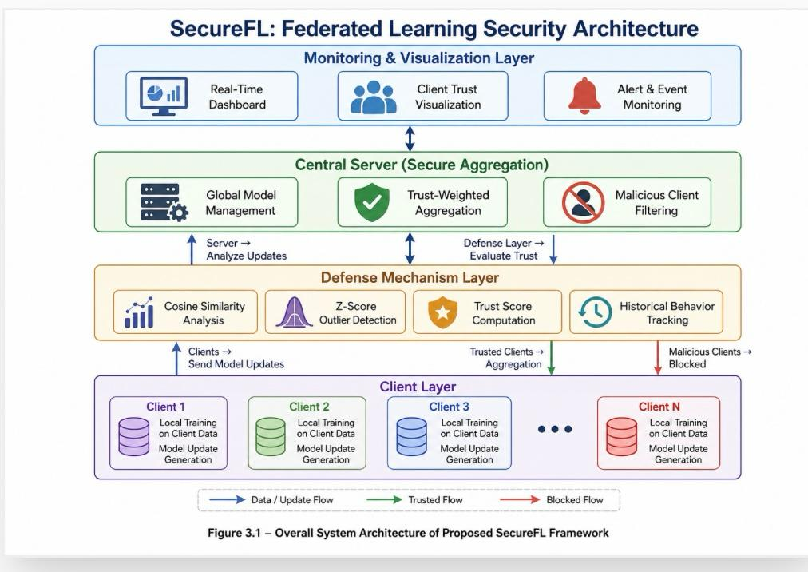
Figure 3.1: SecureFL Federated Learning Security Architecture

The system includes data preparation and feature extraction, model training, and a multi-faceted defence mechanism. It employs similarity-based, statistical, trust-based, and restrained aggregation strategies to detect and mitigate faulty client behaviours during the training process.

Furthermore, this project adopts two approaches. The first approach involves a simple interpretable model with similarity and trust-based defenses, while the second approach involves the extension of the system using advanced technologies such as a multi-layer perceptron (MLP), robust aggregation, and differential privacy. This makes it possible to assess the system in simple and complex attack scenarios, respectively.

Overall, this chapter presents a comprehensive overview of the system design, workflow and approach taken to secure and enhance federated learning systems.

System Overview

The system is designed as a secure federated learning system that controls clients in the training process. The system adopts a workflow where many clients engage in joint learning, and a server coordinates the training and enforces security measures to safeguard the model.

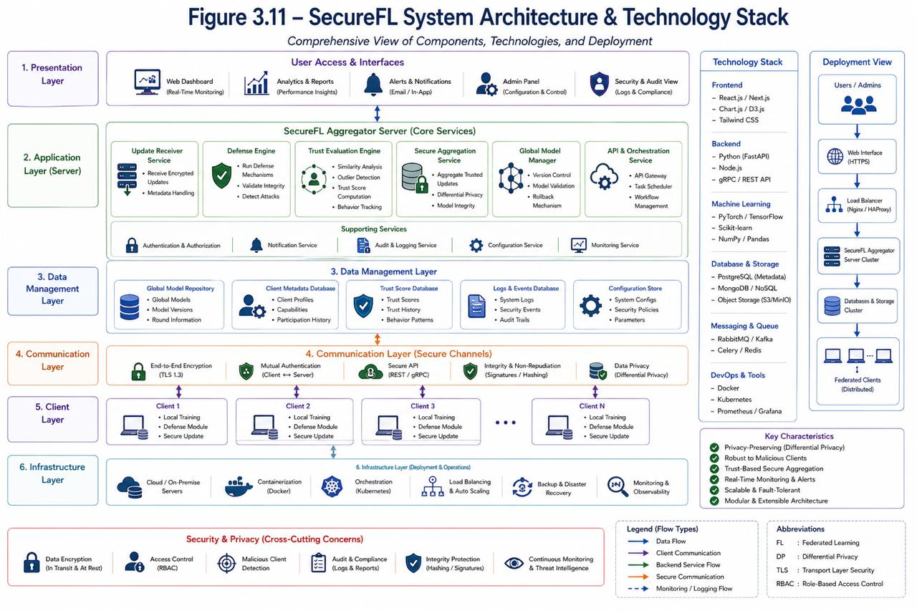
Figure 3.2: SecureFL System Architecture & Technology Stack

The global model is broadcast to all clients in each iteration of the learning process. Clients train the model on their local data and produce updates. The server receives the model updates from clients. Rather than simply aggregating these updates, the system performs a number of tests to examine their quality and consistency.

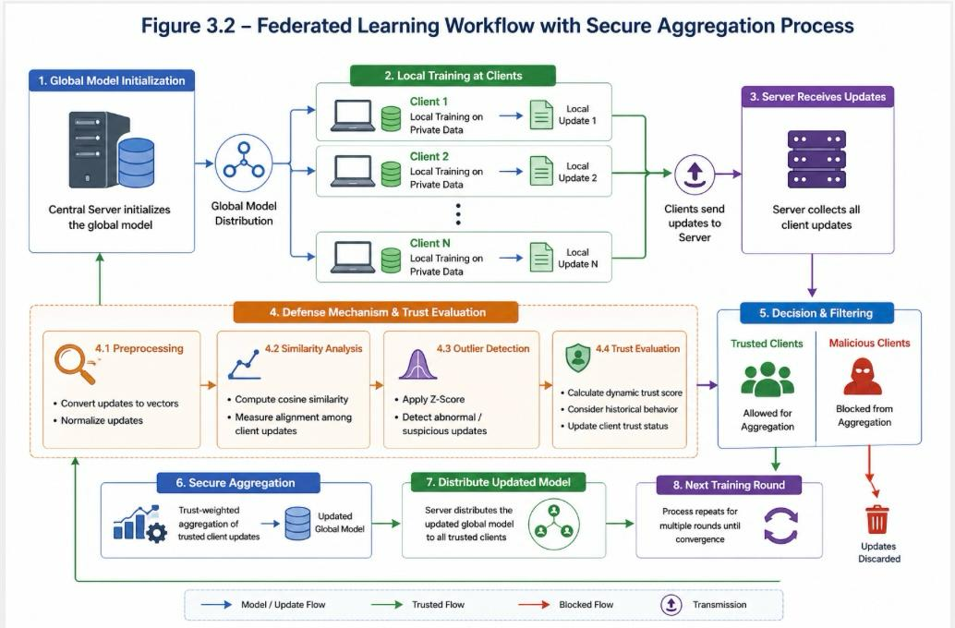
Figure 3.3: Federated Learning Workflow with Secure Aggregation Process

The updates are vectorised and normalised for comparison. It then conducts similarity comparisons using cosine similarity to compare client updates. Outlier detection based on statistical Z-score is used to detect suspicious updates.

Once abnormalities are detected, the system assesses the trustworthiness of clients by calculating their dynamic trust score. It has been decided at aggregation of both current updates made through his/her own clients and their client’s cumulative historic client update activities. Each update gives a score for that client depending upon its reliability to all ‘reliable clients’ have had no history of being unreliable. However, if a client’s updates are not consistent with normal behaviour, then they will receive a lower score.

Lastly, scores are only reviewed when updates are calculated for each round of aggregated submissions. This involves a trust-based aggregation, where trusted clients have a greater influence on the global model. Clients with low trust values are identified and excluded from the aggregation. The new global model is then shared with all clients; this process repeats for several rounds.

The system also offers an interactive dashboard that displays the client trust, participation, and detection results in real-time. The dashboard identifies malicious clients and shows when they are excluded from contributing to the global model. It also raises security alarms, allowing the system to be monitored during training.

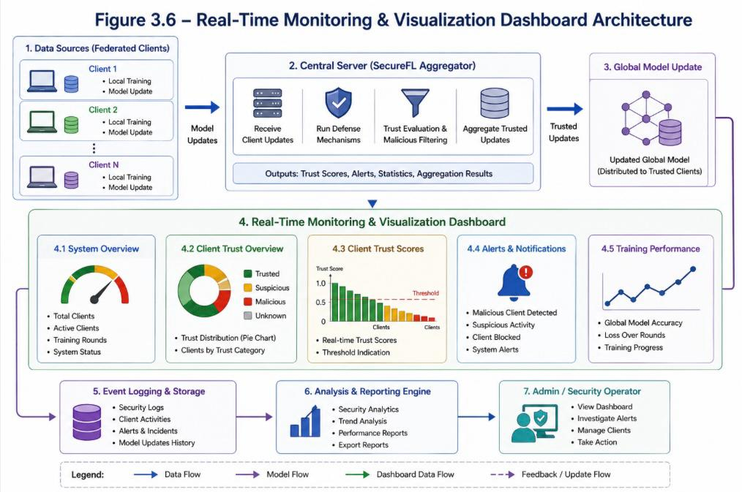
Figure 3.4: Real-Time Monitoring & Visualization Dashboard Architecture

This pipeline guarantees the security of the federated learning system by identifying anomalous behaviour, assessing client trustworthiness, and preventing malicious updates during training.

Proposed Framework

Our framework is a multi-layered security mechanism designed to detect and manage malicious client updates in the federated learning process. So, rather than relying on a single approach, it uses multiple approaches to ensure secure and accurate model training. The system has three layers of operation: detection, behaviour analysis, and decision making.

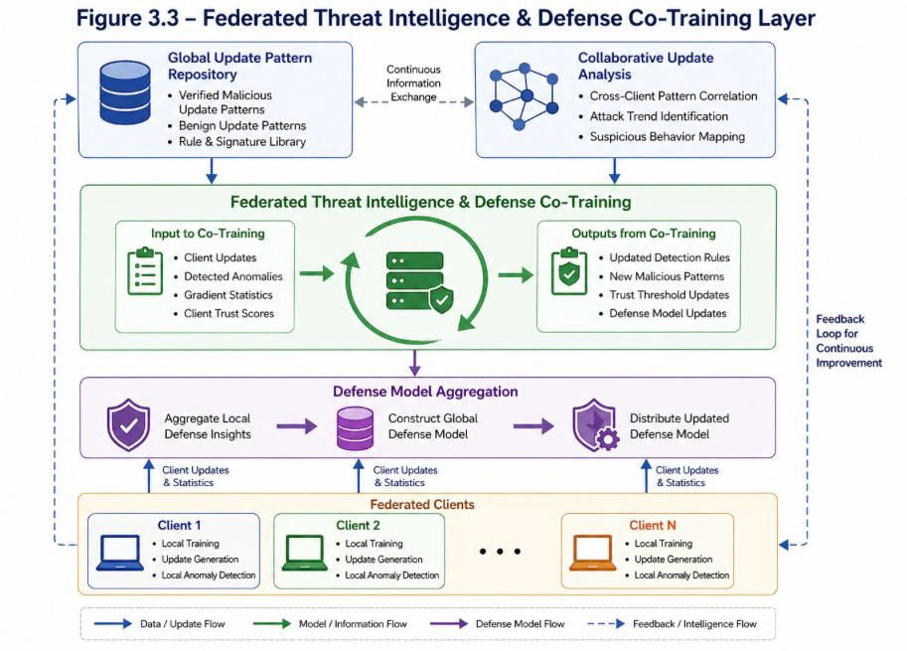
Figure 3.5: Federated Threat Intelligence & Defense Co-Training Layer

- Detection Layer
The first layer is used to detect unusual client updates. Once the updates are received from all the clients, they are converted to numerical values and compared using cosine similarity. This allows to determine how similar each client update is to the rest of the updates in the same training round.

Further, outlier detection is performed using Z-scores. If a client update is different from others, it is considered suspicious.

- Behaviour Analysis Layer
The second layer deals with the analysis of client behaviour. The trust score of each client is dynamic and depends on the quality of the updates it produces. Well-behaved clients have high trust scores, while clients that continue to produce abnormal updates have lower trust scores.

It also considers past performance over several rounds of training.

- Decision Layer
The final layer is responsible for aggregating the global model. A trust weighted aggregation is used. Low trust clients are identified and prevented from aggregation.

Overall Working of Framework

Our framework follows a round-based approach with each training round comprising client update, sharing, defence and secure aggregation. This defence-in-depth approach makes the framework resilient to a range of simple and sophisticated attacks in federated learning systems.

SecureFL (Approach 1)

The first approach of the proposed system is Secure FL, which aims to develop a simple and interpretable defense system for federated learning.
This approach employs hashing vectorization and logistic regression with stochastic gradient descent (SGD). The system uses cosine similarity, statistical filtering (based on Z-score) and gradient clipping (based on differential privacy) as a defense mechanism.

There is also a trust-based mechanism to assess client behaviour and malicious clients are identified and prevented from participating in the global model. In aggregation, trusted clients have more weight, while malicious clients are not included.

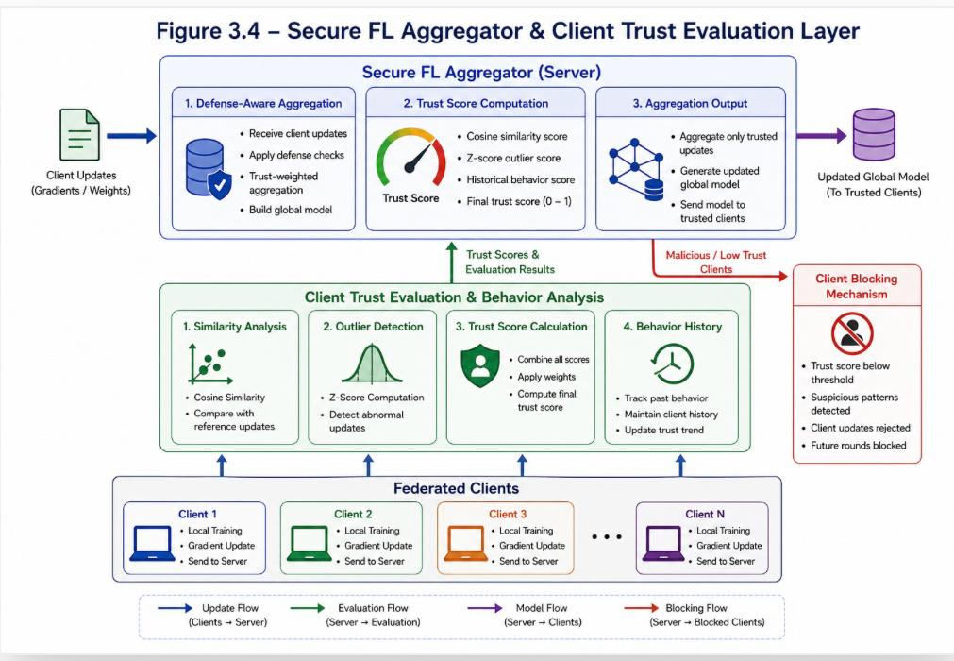
Figure 3.6: Secure FL Aggregator & Client Trust Evaluation Layer

The proposed approach offers a robust baseline protection layer by leveraging efficiency and interpretability with important security features.

Training and Aggregation Process

The proposed approach employs a round-based federated learning protocol where a set of clients jointly learn a global model under the coordination of a server.

In each round, the global model is sent to all clients. The clients train the model locally and provide updates to the server. The updates are then scrutinised for similarities, statistical outliers, and trustworthiness.

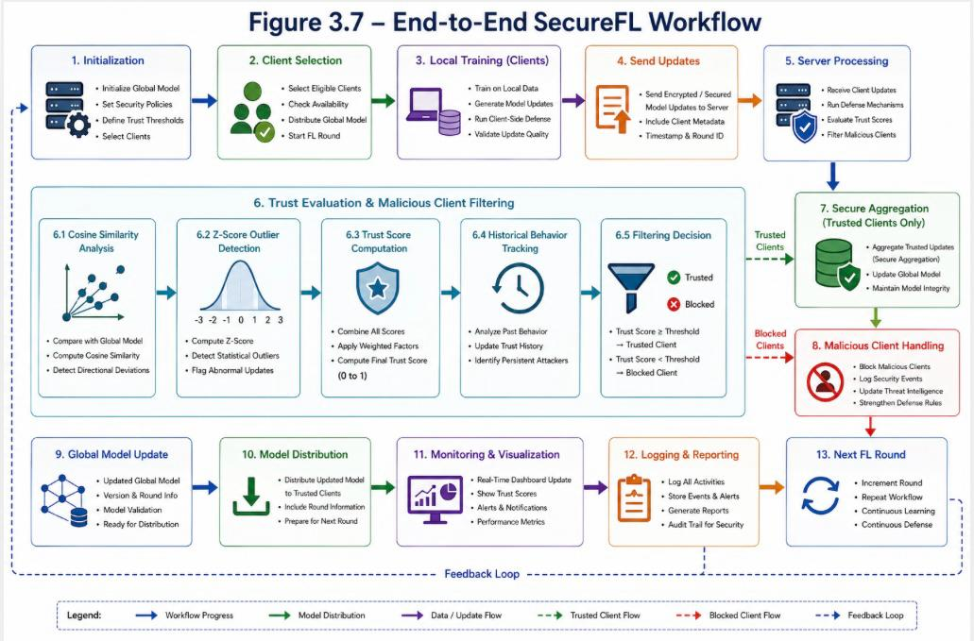
Figure 3.7: End-to-End SecureFL Workflow

Malicious clients are prevented from participating in the aggregation process, thereby ensuring only trustworthy updates are used. The global model is then sent back to the clients for another round.

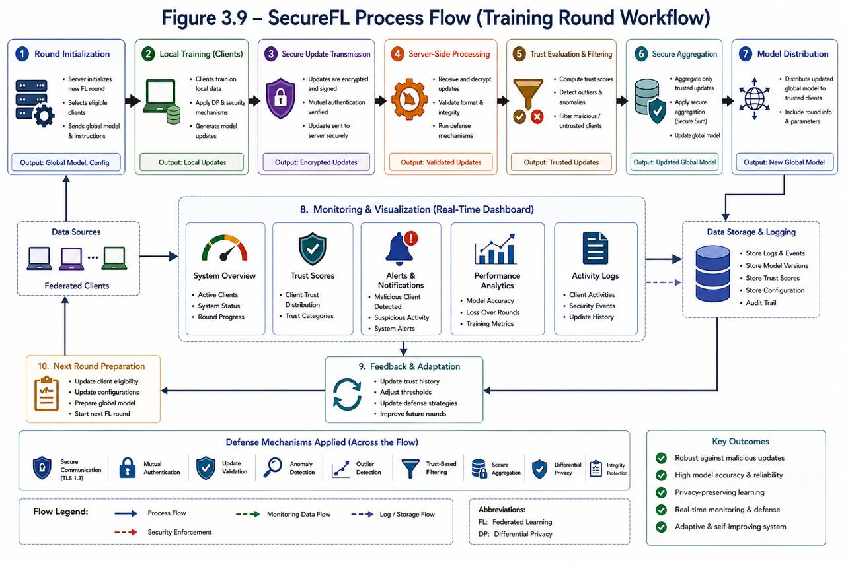
Figure 3.8: SecureFL Process Flow (Training Round Workflow)

The process is monitored in real-time through a dashboard, which shows the behaviour of clients, trust scores, and detection results for each round of training.

Evaluation Setup

The system is evaluated using both single-dataset and cross-dataset experiments to assess performance and generalization.

Normal and adversarial clients are simulated. Malicious activities like label flipping, noise injection and abnormal updates are simulated.

Performance is measured using accuracy, precision, recall, F1-score, ROC-AUC, and Attack Success Rate (ASR). These metrics provide insights into both model performance and security effectiveness.

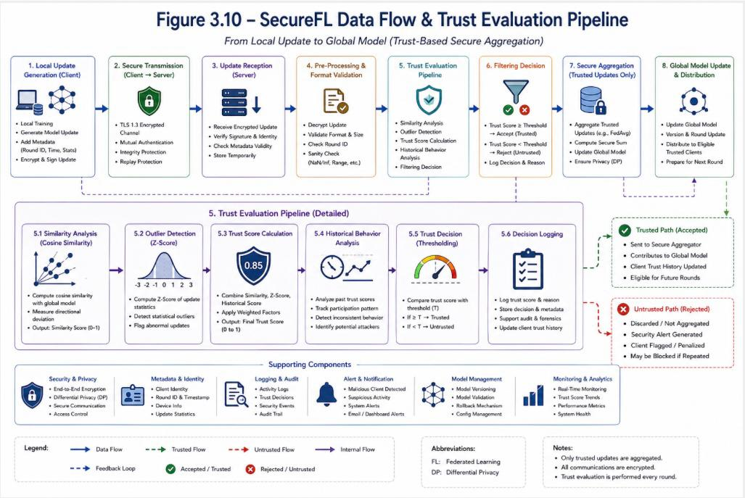
Figure 3.9: SecureFL Data Flow & Trust Evaluation Pipeline

The system dashboard also displays the results to facilitate the understanding of model performance, client behaviour, and security.

System Design Diagram

This section presents the design diagrams used to represent the structure and workflow of the system.

Flow Chart

Illustrates the overall process from data preprocessing to model aggregation.

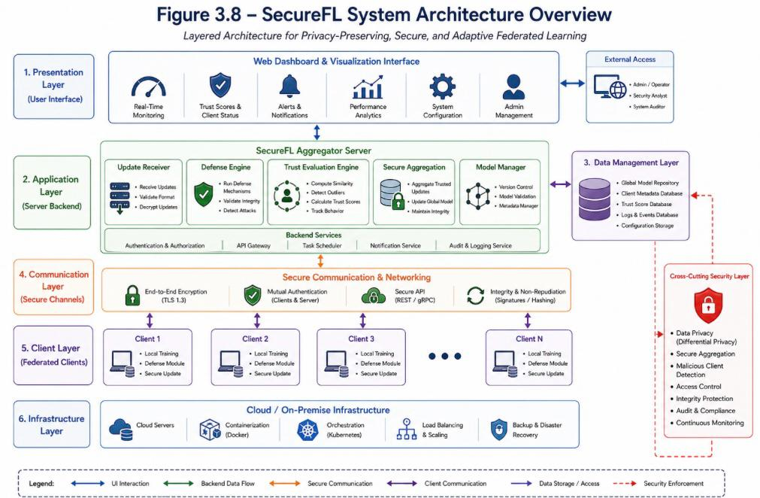
Figure 3.10: Flow Chart of SecureFL System

Use Case Diagram

Shows interactions between clients, server, and administrator.

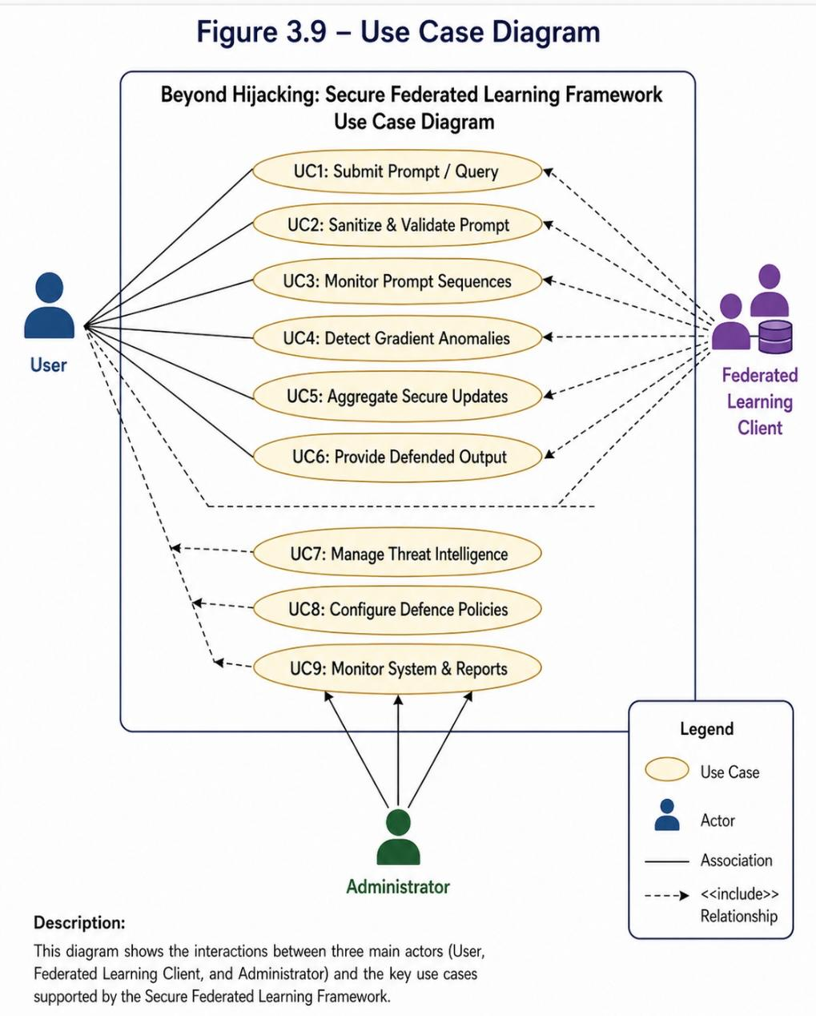
Figure 3.11: Use Case Diagram – Beyond Hijacking Framework

Entity-Relationship Diagram (ERD)

Represents data structure and relationships between system components.

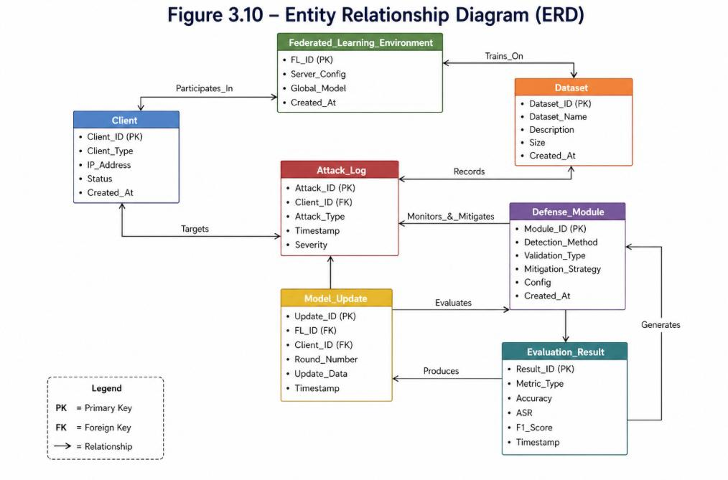Figure 3.12: Entity Relationship Diagram (ERD)

Data Flow Diagram (DFD)

Illustrates how data moves through various stages of the system.

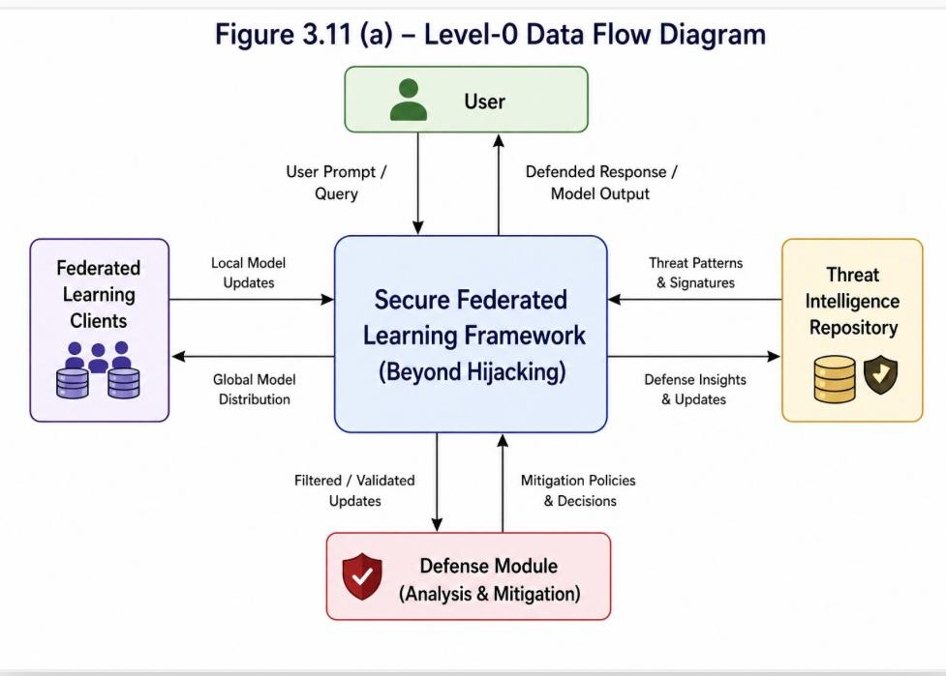
Figure 3.13(a): Level 0 Data Flow Diagram

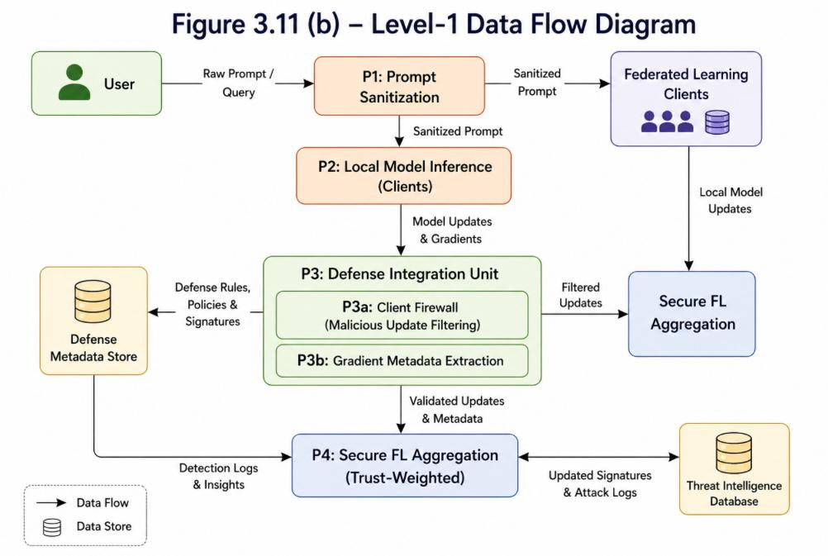
Figure 3.13(b): Level 1 Data Flow Diagram

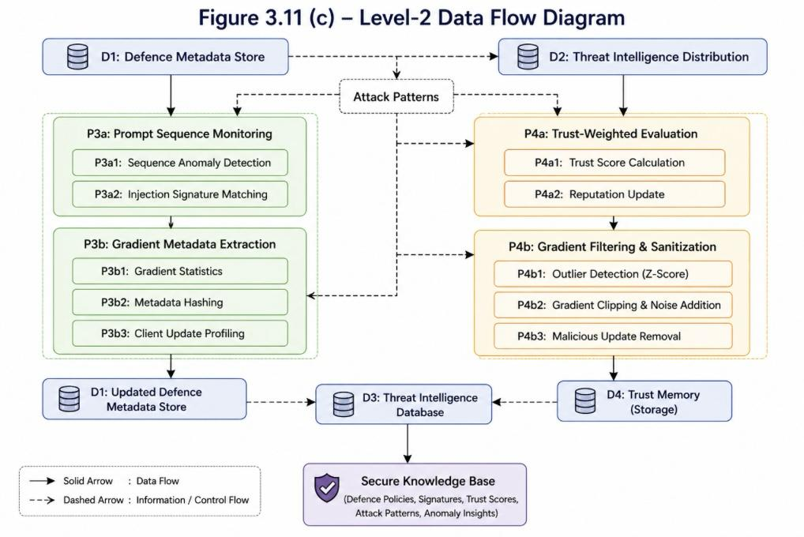
Figure 3.13(c): Level 2 Data Flow Diagram

SUSTAINABLE DEVELOPMENT GOALS (SDG) ALIGNMENT AND IMPACT

Introduction

The United Nations has established 17 Sustainable Development Goals to build a global agenda addressing common challenges such as inequality, poverty, health, education, climate change and technology by 2030. These goals are a collective commitment to action so people can better their lives in a sustainable way.

In this rapidly evolving world of modern technology and engineering, sustainability is much more than an environmental issue. It includes establishing secure, ethical, reliable systems. In addition to artificial intelligence, an increasing number of critical systems are being built with or embraced by distributed systems, but as their number grows, so does the need to ensure the security and resilience of these systems to prevent harm from malicious intent

Computer Science student projects promote sustainable development by innovating solutions to practical problems. The proposed system, "Beyond Hijacking: Secure Federated Learning Framework," will enable sustainable development by enhancing the security and robustness of federated learning systems that are popularly used in privacy preserving and distributed systems.

Selected SDGs Relevant to the Project

The proposed system is relevant to one primary and two secondary SDGs.

The proposed SecureFL approach maps to the selected Sustainable Development Goals as shown below.

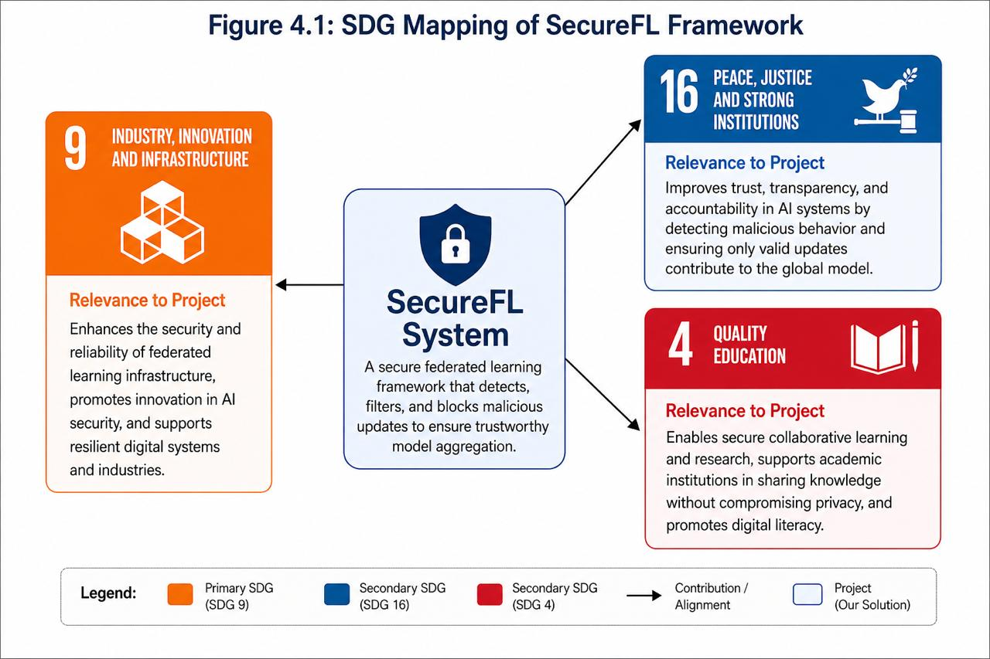
Figure 4.1: SecureFL SDG Mapping

🔹 Primary SDG

SDG 9 – Industry, Innovation, and Infrastructure
- Description
Promote inclusive and sustainable industrial development, and foster innovation.

- Project’s Contribution
The SecureFL system increases the security of federated learning systems. By securing distributed machine learning systems against malicious updates and adversarial attacks, the project helps to establish secure and reliable information infrastructure.

🔹 Secondary SDGs

SDG 16 – Peace, Justice, and Strong Institutions
- Description
Ensure peaceful and inclusive societies for sustainable development, access to justice for all and build effective, accountable, and inclusive institutions at all levels.

- Relevance
This project increases confidence in AI systems by ensuring only legitimate and correct updates are used to train models. This helps achieve transparency and accountability in systems adopted by institutions.

SDG 4 – Quality Education
- Description
Provide inclusive and equitable quality education and promote lifelong learning opportunities for all.

- Relevance
It can help academic and research settings by enabling data privacy preserving collaborative learning.

Project-to-SDG Mapping Explanation

The SecureFL system tackles one of the key issues in federated learning, where client updates can be unreliable and malicious and may harm the global model.

In traditional federated learning, the updates from all clients are considered equally. But in practice, some clients may be malicious or exhibit abnormal behaviours. These updates can affect the model's performance or pose security threats.

The project contributes to sustainable development in the following ways:
- It enhances the trustworthiness of distributed AI systems by screening updates.
- It enhances digital security with secure aggregation.
- It encourages innovation in AI security through trust and anomaly detection.
- It allows safe deployment of federated learning systems.
- It facilitates private learning by maintaining data on the clients.

These benefits ensure federated learning systems are safe, efficient, and reliable, contributing to sustainable development.

The figure below shows the shift from the current challenges to the proposed SecureFL solution, and how it contributes to sustainable development.

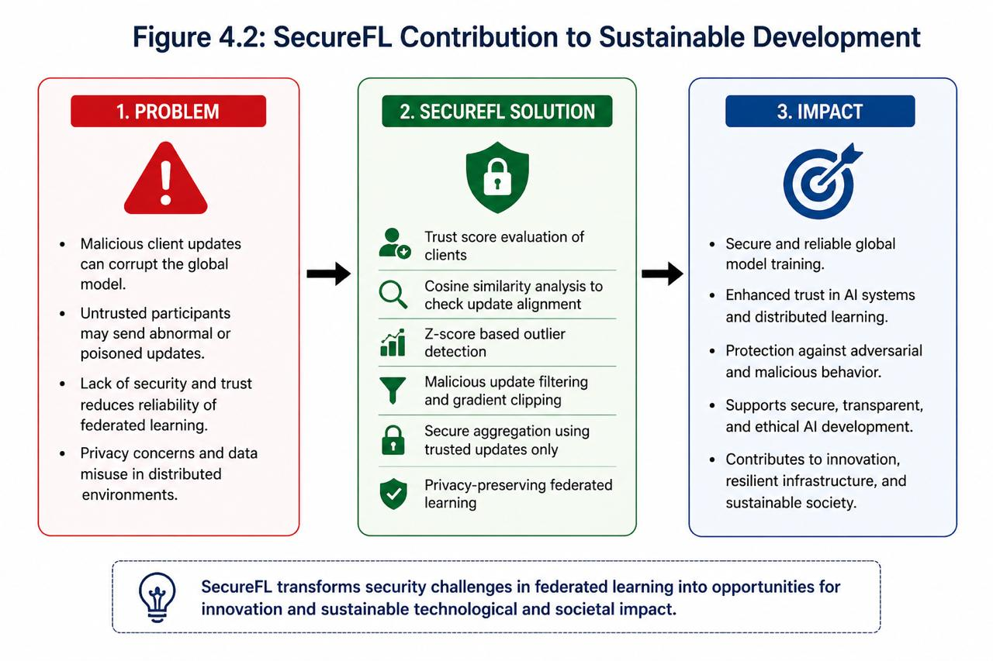
Figure 4.2: SecureFL Contribution to Sustainable Development

SDG Targets and Indicators Alignment

The project contributes to specific SDG targets as follows:

🔹 SDG 9.5 – Enhance scientific research and technological capabilities

- Contribution
Our project proposes a secure federated learning system with sophisticated mechanisms such as anomaly detection, trust score, and secure aggregation, which enhances technological innovation.

🔹 SDG 16.6 – Develop effective, accountable, and transparent institutions

- Contribution
The system prevents malicious model updates and ensures models are trained, which aids transparency and accountability in AI systems.

🔹 SDG 9.c – Increase access to information and communication technology

- Contribution
This system facilitates secure deployment of decentralised learning platforms, driving the use of secure technologies. The following figure illustrates the proposed system alignment with SDG targets and its impact on each goal.

The following figure shows the alignment of the proposed system with specific SDG targets and how it contributes to each objective.
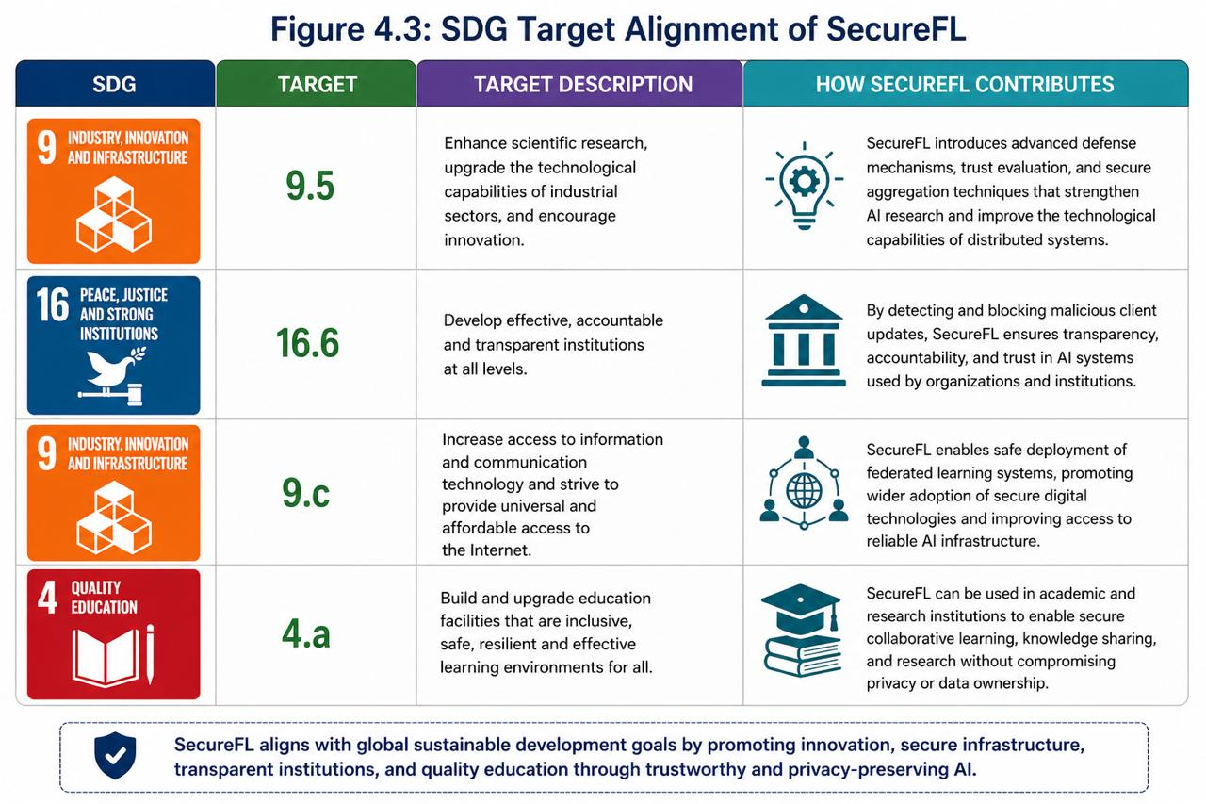
Figure 4.3: SDG Target Alignment of SecureFL

Expected Impact and Benefits

The SecureFL system is anticipated to have a multi-dimensional impact on the security, efficiency and reliability of distributed AI systems.

The proposed system is anticipated to have a significant impact on social, economic, environmental, and technological fronts.

The diagram below shows the multi-dimensional impact of the SecureFL system on social, economic, environmental and technological aspects.

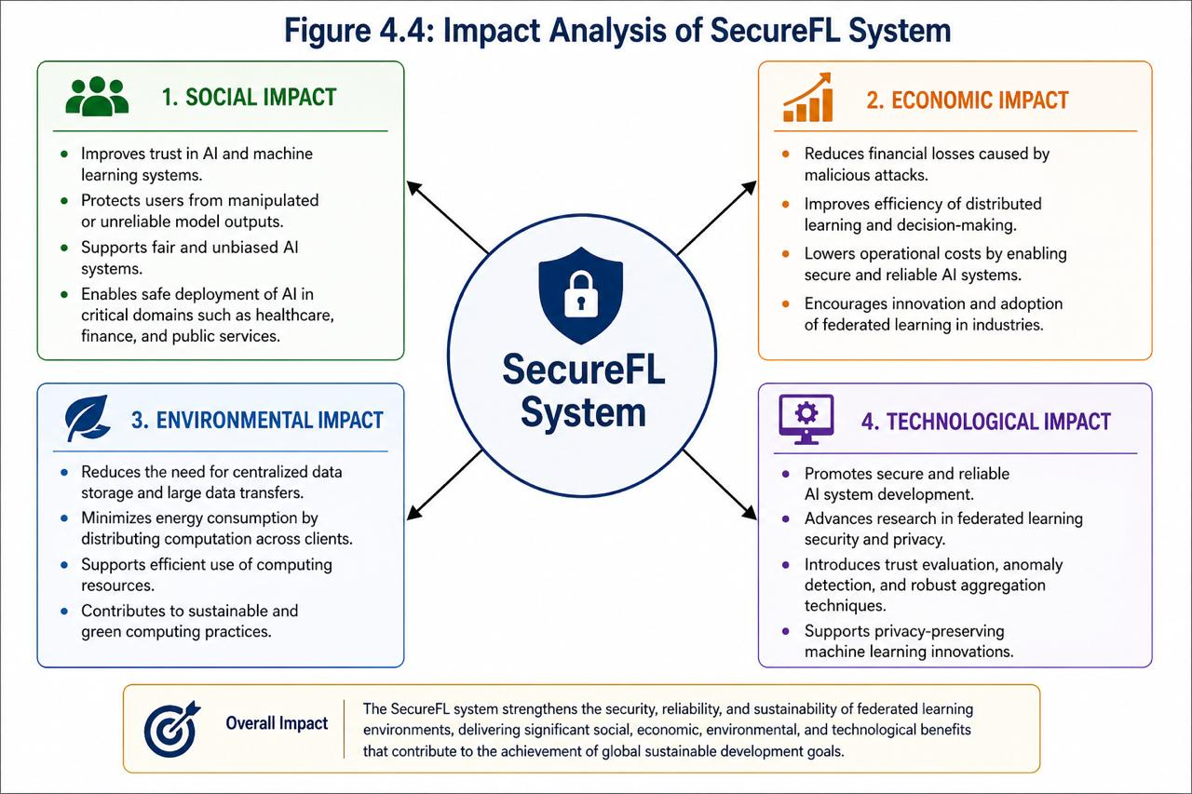
Figure 4.4: Impact Analysis of SecureFL System

Social Impact

- Improves trust in AI systems used in real-world applications
- Protects users from manipulated or unreliable outputs
- Supports secure deployment in sensitive domains such as healthcare and finance

Economic Impact

- Reduces risks and losses caused by malicious attacks
- Improves efficiency of distributed machine learning systems
- Supports innovation in business and industrial applications

Environmental Impact

- Reduces the need for centralized data storage
- Minimizes data transfer and energy consumption
- Supports efficient use of distributed computing resources

Technological Impact

- Promotes secure and reliable AI development
- Enhances federated learning frameworks
- Introduces trust-based aggregation mechanisms
- Supports privacy-preserving machine learning techniques

Stakeholders and Beneficiaries

The following table presents the stakeholders of the proposed system along with the benefits associated with each.

Table 4.1: Stakeholders and Their Expected Benefits
Stakeholder | Benefit
Users | Secure and reliable AI-based services
Organizations | Reduced risk and improved system performance
Researchers | Safe and collaborative learning environments
Government | Trustworthy systems for decision-making
Society | Ethical and secure technological development

The figure below shows the major stakeholders of the system and the benefits they get.

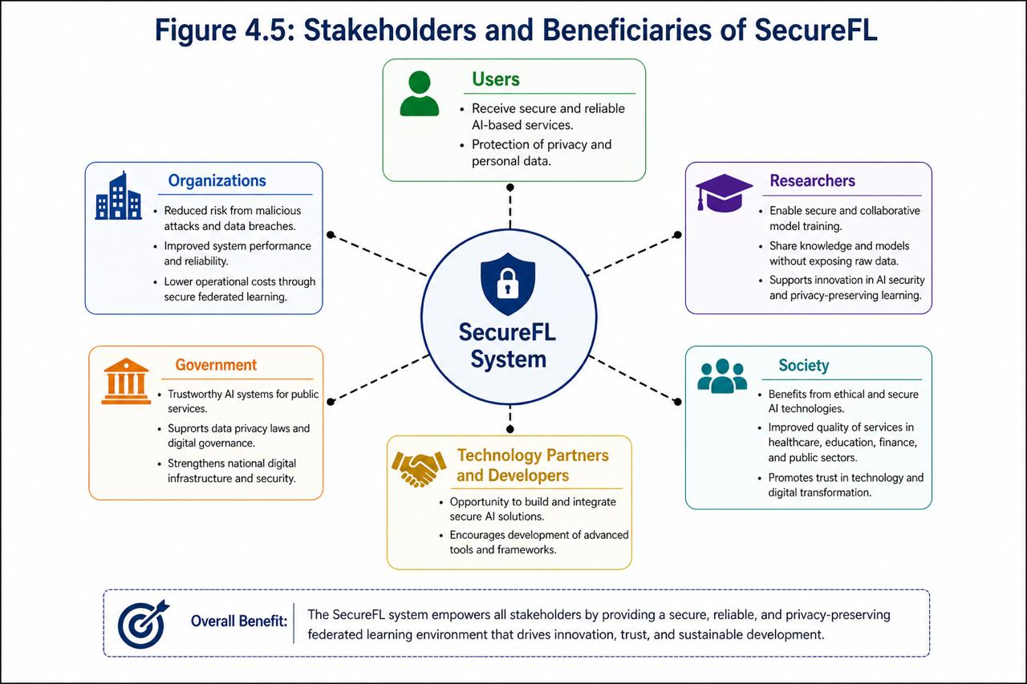
Figure 4.5: Stakeholders and Beneficiaries of SecureFL

Ethical and Sustainability Considerations

The system is developed using ethical and sustainable practices to ensure the ethical use of artificial intelligence in distributed systems.

- Ethical Considerations
- Data Privacy
No data is directly transferred from client.
- Security
Potentially harmful updates are filtered out before aggregation.
- Ethical AI Usage
The system prevents biased or manipulated contributions.
- Transparency
Trust scores provide insight into client behaviour.

- Sustainability Aspects
- Sustainability
Decentralised learning minimises reliance on centralised services.

SDG Mapping Table

The table below shows the mapping of the project to Sustainable Development Goals (SDGs).

Table 4.2: SDG Mapping of Project Contributions
Project Component | SDG | Target | Contribution
Federated Learning  Framework | SDG 9 | 9.5 | Supports technological  innovation
Trust Evaluation  Mechanism | SDG 16 | 16.6 | Ensures transparency  and reliability
Secure Aggregation | SDG 9 | 9.c | Strengthens digital  infrastructure
Privacy Preserving  Techniques | SDG 16 | 16.6 | Enhances secure data  handling

Future Scope for SDG Enhancement

The project can be further expanded in the future to promote sustainable development:
- Deployment in real world industrial systems
- Integration with smart city applications
- Use in healthcare and financial AI systems
- Scaling to large, distributed environments
- Implementation of advanced privacy techniques

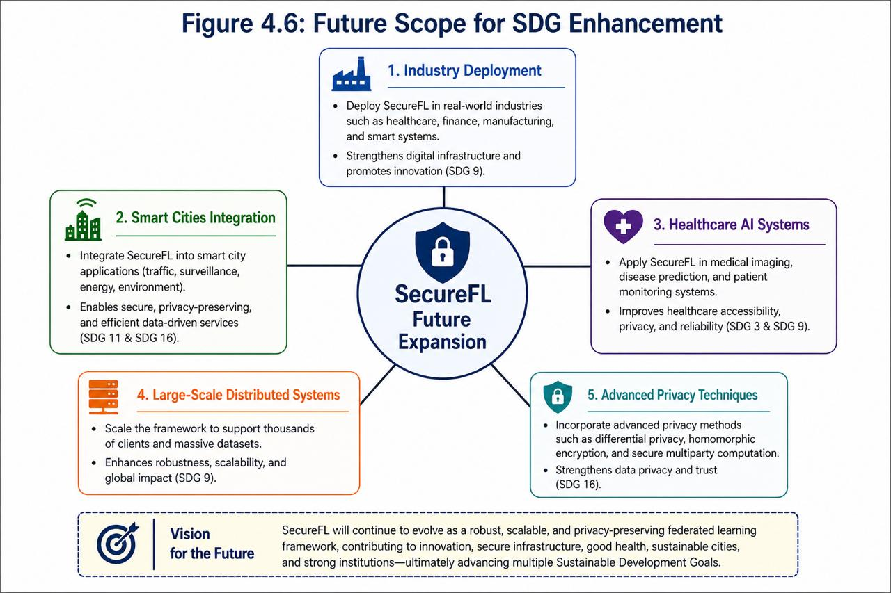
Figure 4.6: Future Scope for SDG Enhancement

Chapter Summary

This chapter explained how the proposed SecureFL system supports Sustainable Development Goals. The project addresses SDG 9 and SDG 16 by improving the security, trustworthiness, and transparency of federated learning.

Through its capability to detect and block malicious updates, the system supports the creation of secure and reliable AI systems. The proposed system demonstrates that by leveraging the benefits of secure and ethical AI systems, we can create modern technologies and further develop existing ones in an environmentally friendly manner while providing value and benefiting society.

DATA, EXPERIMENTS, and IMPLEMENTATION

Introduction

This chapter describes the experimentation of the proposed Secure Federated Learning (SecureFL) framework. It describes the datasets, experimental setup, and results under real-world and controllable adversarial settings.

The goal of this chapter is to:

- Explore SecureFL's ability to detect prompt injection attacks
- Compare SecureFL to a baseline federated learning model
- Assess resistance to client attacks
- Investigate the security-accuracy trade-off

We consider two experiments to evaluate the effectiveness and generalization capability of the proposed system:

- Experiment 1: Evaluation on Prompt Injection in the Wild dataset [82]
- Experiment 2: Explicit evaluation using different datasets (PIDTC for training, PIDEC for testing) [83]

Performance is assessed using standard metrics (accuracy, precision, recall, F1-score, ROC-AUC) and a critical security metric, Attack Success Rate (ASR), which quantifies how often adversarial updates succeed in influencing the model. The goal is to demonstrate that improving security also stabilizes and enhances learning performance.

Prompt Injection in Federated Learning

Prompt injection is a significant vulnerability in current AI systems, especially in natural language processing. In this type of attack, attackers inject covert or harmful commands in the input prompts to trigger unexpected behaviours in the model.

In federated learning environments, this issue becomes more severe due to the decentralized nature of training. Each client trains locally and only shares model updates, which creates an opportunity for malicious clients to inject harmful updates into the global model.

To simulate realistic attacks, this project adopts:

- Trigger-based prompt injection
- Poisoning via backdoored weights

These processes enable evaluating the system in real-world adversarial settings.

Dataset Used

This work adopts two approaches to dataset to assess real-world performance and controlled robustness.

Experiment 1 Dataset

The first experiment uses a real-world dataset:
- Prompt Injection in the Wild Dataset [82]

This is a set of realistic prompt injection samples, some are benign and some are malicious. This is a real-world, unstructured, and noisy dataset, without a clear train-test split.

This dataset is used to evaluate:

- Generalization capability
- Real-world robustness
- Robustness against unexpected inputs

Experiment 2 Dataset

The second experiment uses the collected dataset:
- Prompt Injection Detection Corpus V1 (PIDC) [83]

Dataset Statistics

It consists of the following

- Training Corpus: Prompt Injection Detection Training Corpus (PIDTC)

- Total Samples: 120,049
- Malicious Samples: 39,425
- Safe Samples: 78,352

- Evaluation Data: Prompt Injection Detection Evaluation Corpus (PIDEC)

- Total Samples: 70,861
- Malicious Samples: 14,089
- Safe Samples: 56,772

Use of the Dataset in Experiment 2

The dataset is used strategically

- PIDTC → Training at federated clients
- PIEDC → Testing

Triggers are injected in the test phase to calculate Attack Success Rate (ASR).

Class Imbalance

The datasets are imbalanced to reflect the real world, where malicious inputs are rare but important to detect.

Difference in Experiments

The following table highlights the key differences between Experiment 1 and Experiment 2.

Table 5.1: Comparison of Experimental Setups
Aspect | Experiment 1 | Experiment 2
Dataset | Single | Separate train/test
Environment | Real-world | Controlled
Goal | Generalization | Evaluation

Experimental Setup

The system is designed to simulate a federated learning system:

- Number of Clients: 5
- Communication Rounds: 10
- Malicious Clients: 1
- Feature Extraction: TF-IDF + LSA (300 dimensions)

Model Architecture

A neural network model is used:

- Input Layer (LSA features)
- Hidden Layer 1 (512 neurons, ReLU + Dropout)
- Hidden Layer 2 (128 neurons, ReLU)
- Hidden Layer 2 (128 neurons, ReLU)

Baseline Model

The baseline is based on Federated Averaging (FedAvg):

- No filtering
- All client updates accepted

SecureFL Model

SecureFL introduces:

- Trust-based scoring
- Cosine similarity validation
- Malicious update filtering
- Differential privacy noise
- Adaptive thresholding

Evaluation Metrics

The following metrics are used:

  - Accuracy
  - F1-score
  - Precision and Recall
  - Attack Success Rate (ASR)
  - AUROC and AUPRC

Experiment 1: Prompt Injection in the Wild

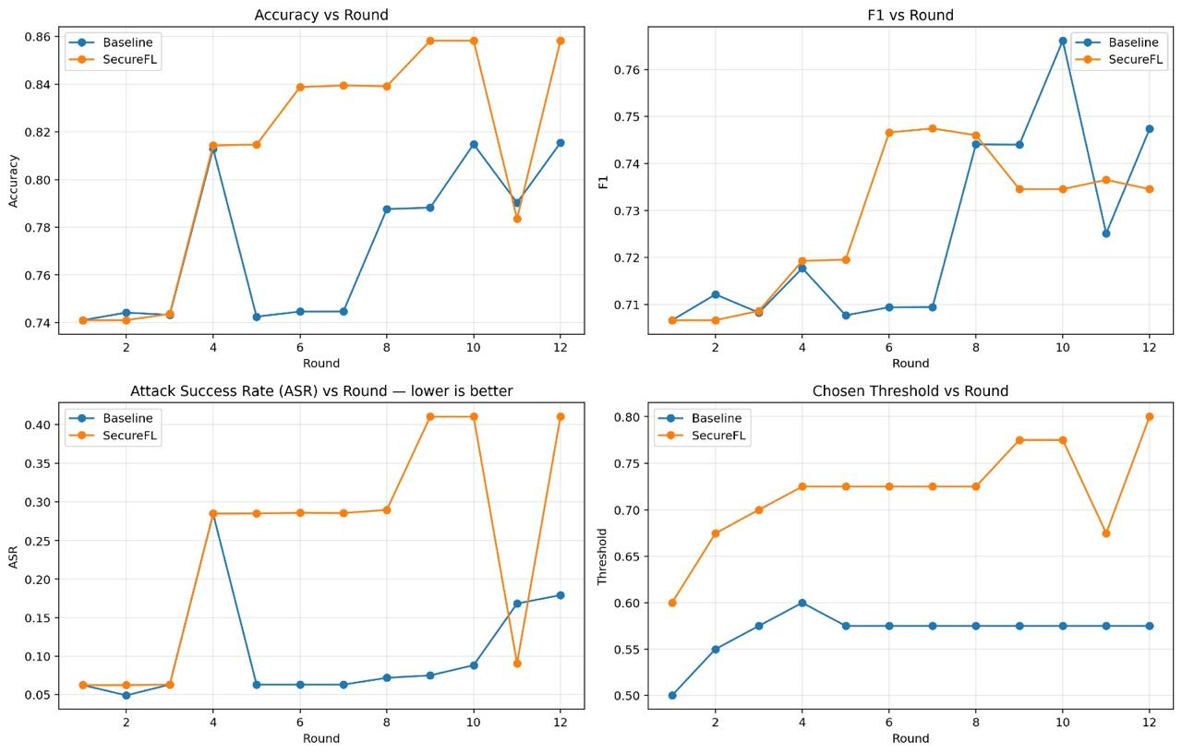
Figure 5.1: Accuracy vs Round (Experiment 1)

SecureFL consistently outperforms the baseline in terms of accuracy, showing enhanced learning in practical settings.


Figure 5.2: F1 Score vs Round (Experiment 1)

SecureFL has consistent and higher F1-score, meaning it has a better balance between precision and recall.


Figure 5.3: ASR vs Round (Experiment 1)

SecureFL has a lower attack success rate and is robust to adversarial information.


Figure 5.4: Threshold vs Round (Experiment 1)

Adaptive thresholding helps us make better decisions.

Experiment 2: Results on PIDTC and PIDEC

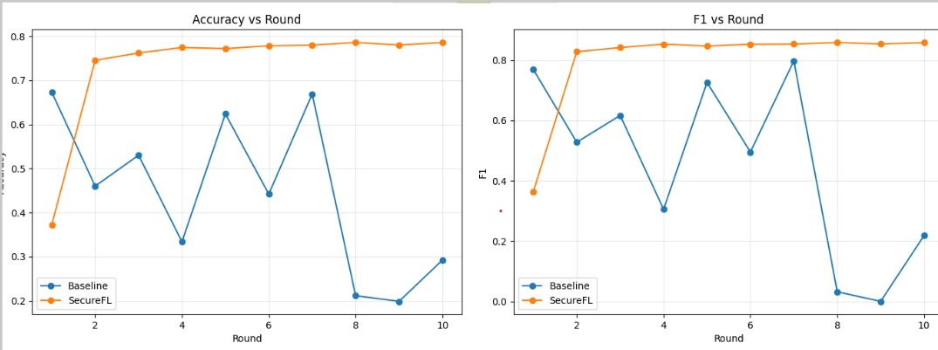
Figure 5.5: Accuracy vs Round (Experiment 2)

SecureFL is considerably better in controlled attacks.


Figure 5.6: F1 Score vs Round (Experiment 2)

SecureFL achieves better results in identifying malicious inputs.

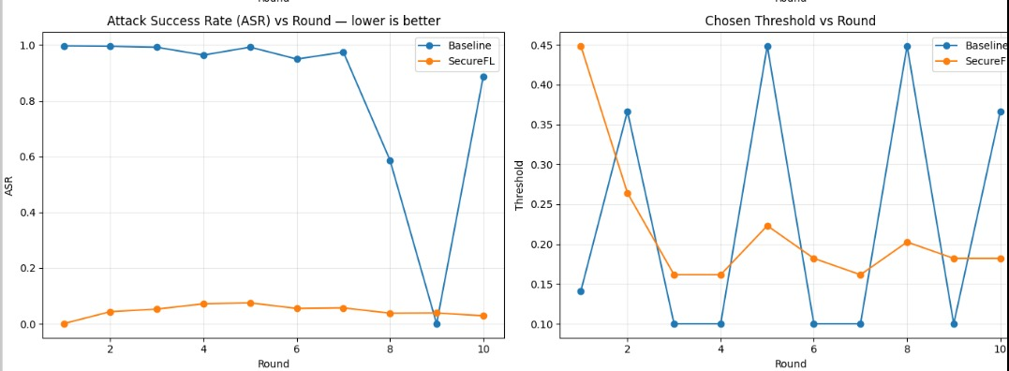
Figure 5.7: ASR vs Round (Experiment 2)

SecureFL has a strong impact on the attack success.


Figure 5.8: Threshold vs Round (Experiment 2)

Threshold automatically adjusts to performance.

Additional Evaluation and Analysis

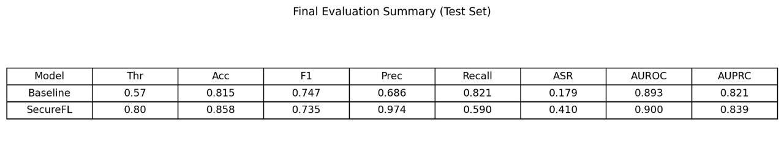
Figure 5.9 (a): Final Evaluation Metrics (Experiment 1)

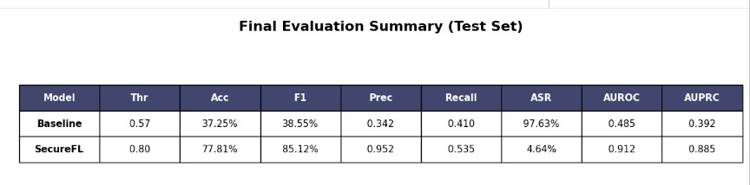
Figure 5.9 (b): Final Evaluation Metrics (Experiment 2)

SecureFL performs better.

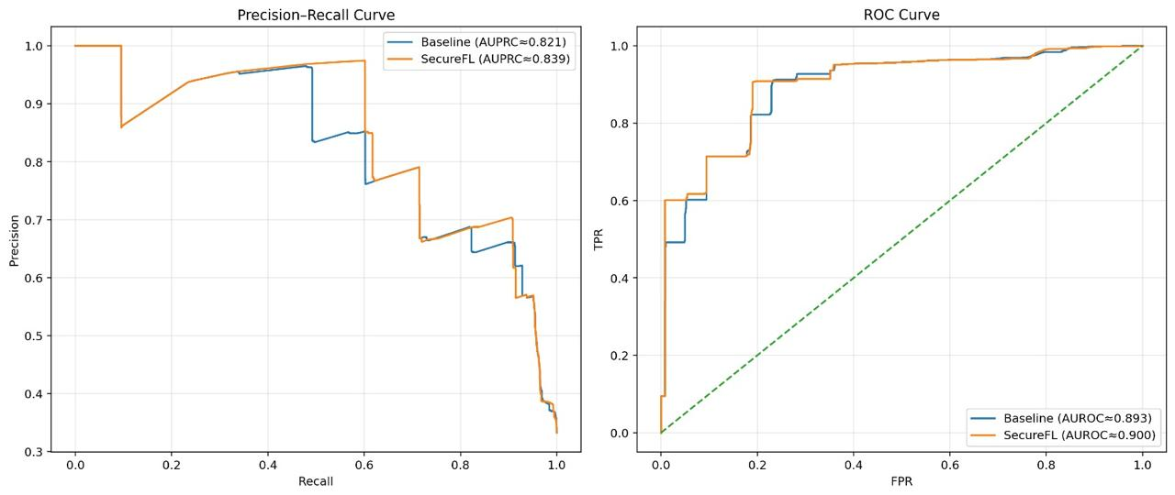
Figure 5.10 (a): ROC Curve (Experiment 1)

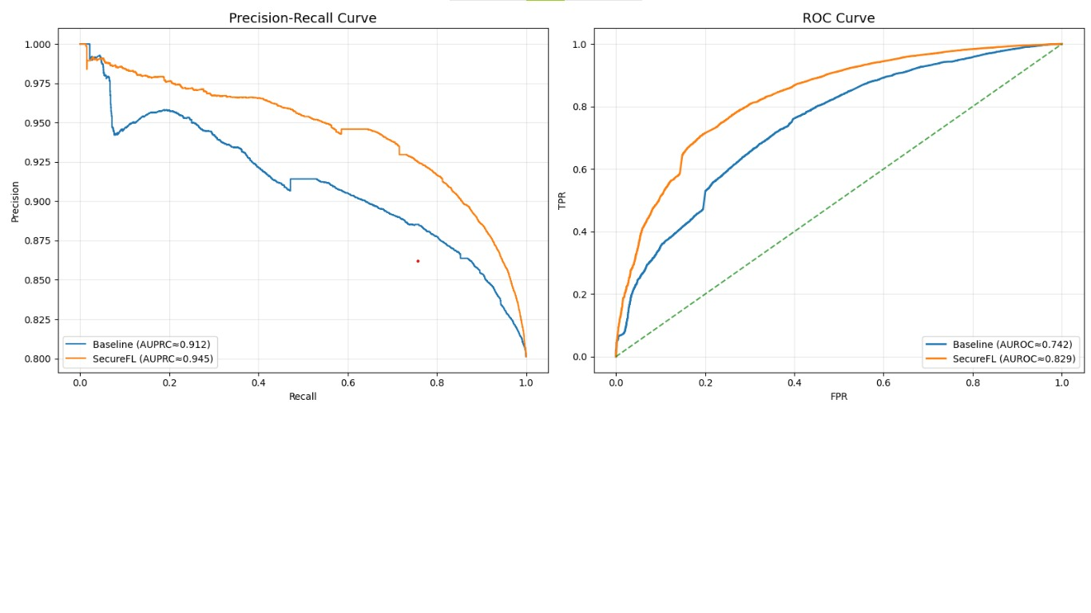
Figure 5.10 (b): ROC Curve (Experiment 2)

SecureFL is better able to classify data points.


Figure 5.11 (a): Precision-Recall Curve (Experiment 1)


Figure 5.11 (b): Precision-Recall Curve (Experiment 2)

Better performance on imbalanced data.

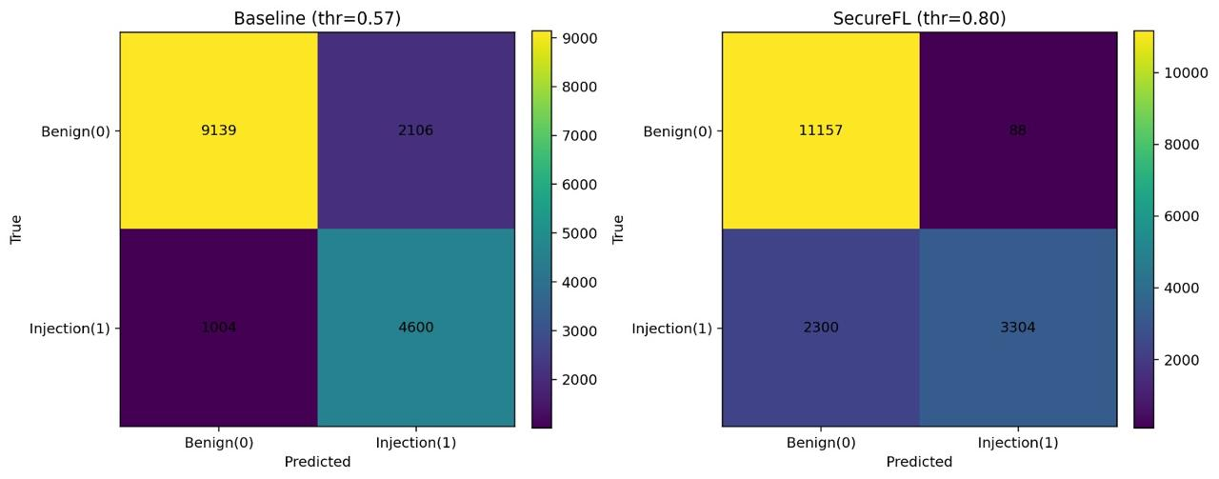
Figure 5.12 (a): Baseline Confusion Matrix (Experiment 1)

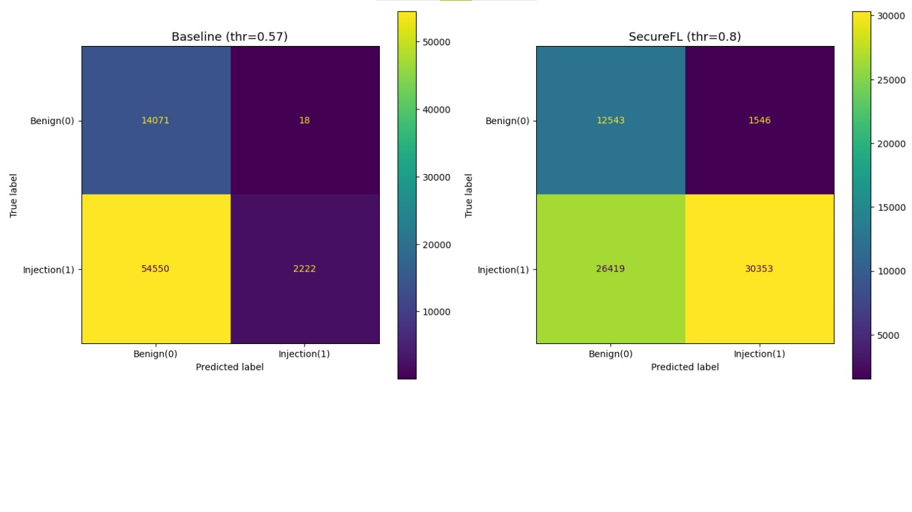
Figure 5.12 (b): Baseline Confusion Matrix (Experiment 2)

Baseline has more misclassification.


Figure 5.13 (a): SecureFL Confusion Matrix (Experiment 1)


Figure 5.13 (b): SecureFL Confusion Matrix (Experiment 2)

SecureFL improves detection accuracy.

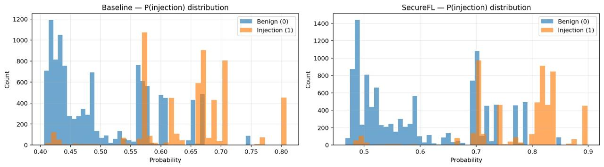
Figure 5.14 (a): Probability Distribution Baseline vs SecureFL (Experiment 1)

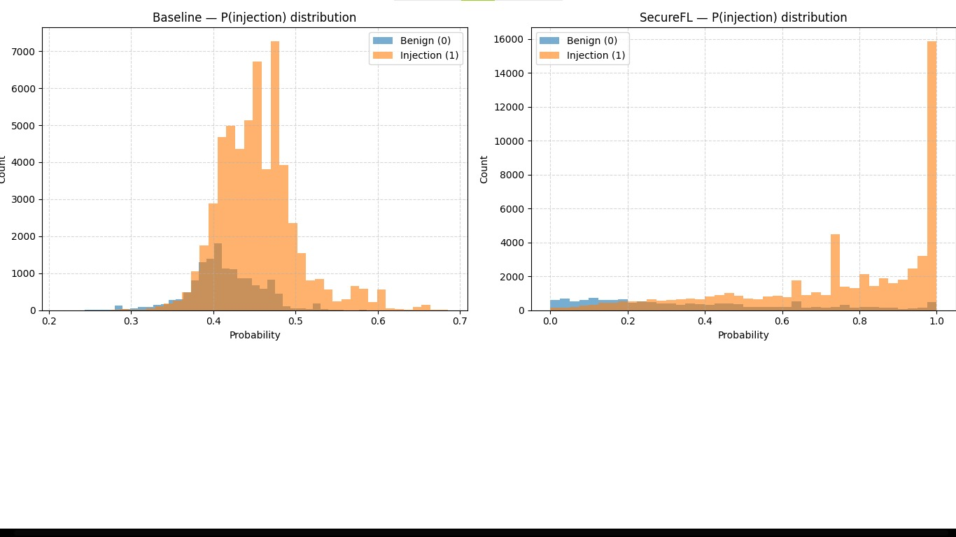
Figure 5.14 (b): Probability Distribution Baseline vs SecureFL (Experiment 2)

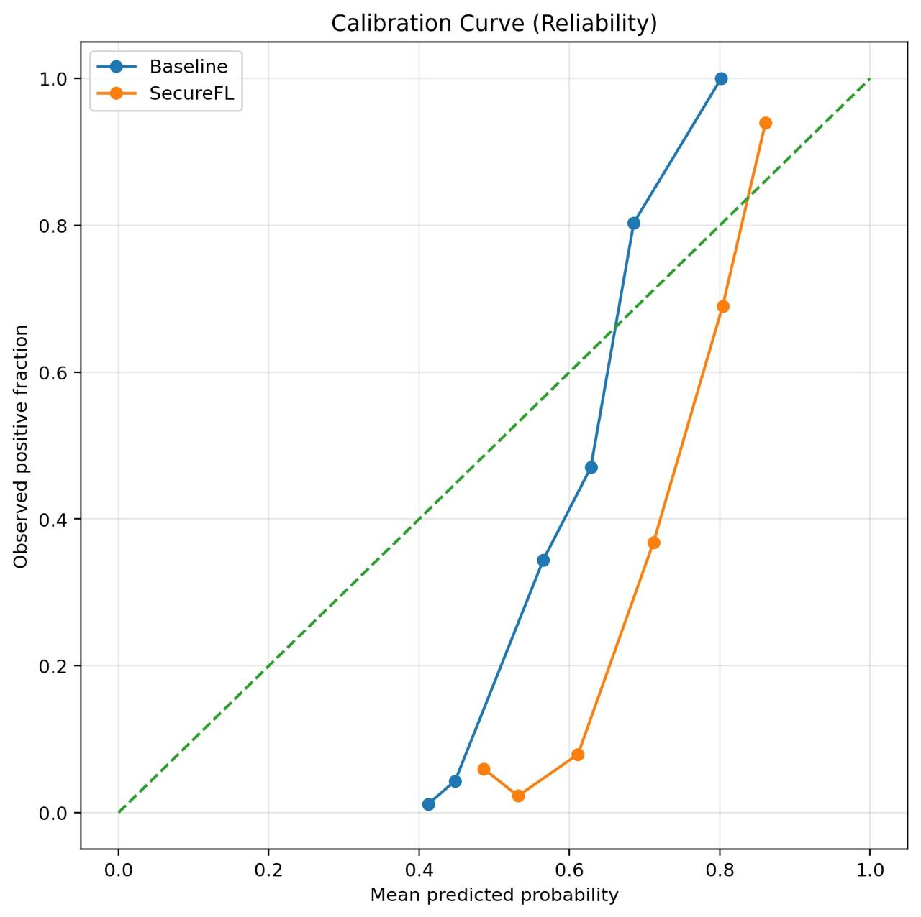
Figure 5.15 (a): Calibration Curve (Experiment 1)

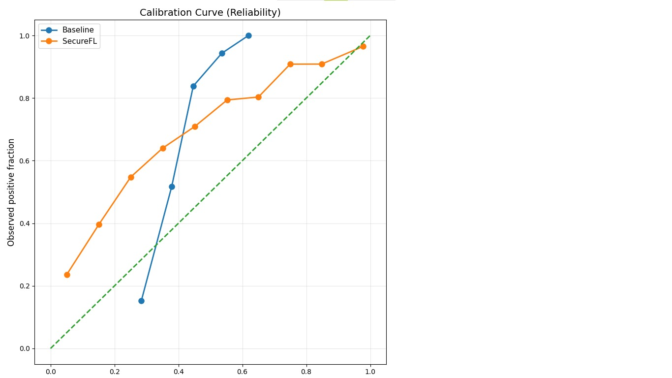
Figure 5.15 (b): Calibration Curve (Experiment 2)

These additional figures also confirm the robustness, calibration, and security.

The advancement of communication rounds has shown that with SecureFL the learning behavior is improving:

- The convergence of the global model is becoming more consistent and less erratic (not subject to being disrupted by bad client information).
- There will be less influence from clients who provide malicious updates, since they will be removed from the system on an ongoing basis.
- A more robust system because the adjustment of the trust score is performed in real time.

The above characteristics provide SecureFL a unique opportunity to demonstrate stable convergence as well as provide increased robustness for any practical implementation of SecureFL.

Overview of Feature Representation

The ability of SecureFL to identify normal vs. malicious prompts is reliant on extracting feature vectors from text data using standard TF-IDF and LSA techniques.

Malicious prompts may contain hidden commands, keywords, or other irregular patterns. These types of patterns may not readily be visible; however, when converted into a vector format, the patterns become identifiable. In addition, LSA further enhances this process by identifying semantic relationships between words allowing the model to recognise patterns based on context.

For example, adversarial prompts will contain different combinations of terms and also may have semantic discrepancies in comparison to legitimate user queries. These patterns may also be detected within the feature space and therefore learned by the NNM.

Therefore, the model’s ability to comprehend text and differentiate between positive/negative input improves by using TF-IDF and LSA, which is key to enhancing system performance and stability, as shown below:
- Comprehending the text’s meaning
- Understanding if the input is “good” or “bad”
- Eliminating noise and/or redundancy in the data

System-Level Security Interpretation

At the system level, SecureFL converts the federated learning system to a secure system. Rather than being a passive aggregator, it dynamically assesses the trustworthiness of the updates and then integrates them into the global model.

The trust-based and anomaly detection mechanisms introduce a protection layer in the learning process. This layer ensures that:

- Poisonous updates are detected before pooling
- Contributions are either rejected or analysed
- The global model is protected

This method overcomes one of the key challenges of conventional federated learning systems, which do not have inherent safeguards against attacks.

Moreover, the use of cosine similarity and update norm analysis offers an effective approach to identify anomalies in client updates. As a result, the system can function even when an adversary tries to mask its actions.

To summarise, SecureFL enhances the security of federated learning while preserving the decentralisation aspect.

Real World Applications

According to the experiment results, SecureFL would be a suitable platform for real-world scenarios where data privacy and security are highly valued.
A major benefit of federated learning is that it enables training without data sharing. SecureFL extends this benefit by securing the training process against malicious attacks.

Potential application domains include:

- Transactions in financial systems, which need to be securely analysed
- Health, where patient information needs to be protected
- Languages models and AI assistants, which can be subject to prompt injection attacks
- Enterprise systems, where different entities co-operate without exchanging data

The fact SecureFL does not compromise performance while improving security makes it a viable solution for these domains.

RESULTS AND DISCUSSIONS

Analysis of Model Performance

In this section, we provide an in-depth analysis of the proposed Secure Federated Learning (SecureFL) approach to detect prompt injection attacks. We evaluate the performance using two different experimental setups: real world data (Prompt Injection in the Wild) and controlled data (PIDTC for training and PIDEC for testing).

Results (Experiment 1 - Prompt Injection in the Wild)

In the first experiment, the models are evaluated on a real-world prompt injection dataset with noisy, unstructured, and diverse adversarial patterns.

Table 6.1 Results (Experiment 1 - Real World Dataset)
Model | Threshold | Accuracy | F1 Score | Precision | Recall | ASR | AUROC | AUPRC
Baseline | 0.57 | 0.815 | 0.747 | 0.686 | 0.821 | 0.179 | 0.893 | 0.821
SecureFL | 0.80 | 0.858 | 0.735 | 0.974 | 0.590 | 0.410 | 0.900 | 0.8390

- Evaluation of Experiment 1
The classification performance in this real-world experiment has improved with SecureFL. The model's accuracy is improved from 81.5% to 85.8%, showing improved capacity of the model to generalize noisy data. There is a remarkable improvement in the precision with SecureFL at 0.974 compared to 0.686 in the non-privacy-preserving baseline model. This shows that SecureFL is effective in detecting malicious inputs with few false alarms.

The recall rate decreases from 0.821 down to 0.590, and a large number of the malicious samples may be missed because of a restrictive level of filtering based on trust. The designers of the model determined that they would prefer to either have security over the ability to make recalls.

Moreover, the f1-scores are comparable for both models, indicating that although there is an inherent trade-off between precision and recall, the two models perform very similarly.

Finally, the increase in terms of attack success rates (ASR) within the two models from 0.179-0.410 is another important consideration. It is likely because of the difficulty for the models to identify attacks since prompt injection attacks can be prompt injection attacks with an almost identical semantic structure to legitimate data. As such, filters based on accepted semantic structures will help both to recover adversarial inputs and to validate/undo them as legitimate. Also, the higher threshold in SecureFL ensures higher precision, so some semantically similar adversarial samples might be admitted. This shows the need for dynamic threshold adjustment in practical applications.

SecureFL also slightly outperforms in terms of AUROC and AUPRC, suggesting a superior confidence and ranking effectiveness.

So, this experiment shows the effectiveness of SecureFL in real-life scenarios while prioritising security in decision-making.

Results Experiment 2 (PIDTC and PIDEC - Controlled Environment)

In the second experiment, the models are tested in a controlled environment with organised datasets, and PIDTC is used for training and PIDEC for testing.

Table 6.2 Results (Experiment 2 - Controlled Dataset)
Model | Threshold | Accuracy | F1 Score | Precision | Recall | ASR | AUROC | AUPRC
Baseline | 0.57 | 0.3725 | 0.285 | 0.342 | 0.410 | 0.9763 | 0.485 | 0.392
SecureFL | 0.80 | 0.7781 | 0.8512 | 0.952 | 0.535 | 0.046 | 0.912 | 0.885

- Evaluation of Experiment 2
This experiment clearly illustrates the effectiveness of SecureFL against adversarial attacks.

The accuracy of the baseline model is low (37.25%), showing that it cannot learn from malicious updates. The ASR of 97.63% demonstrates that the baseline model is very susceptible to the prompt injection attack.

SecureFL's performance has clearly improved when compared with its previous performance. SecureFL's accuracy improved from 62.38% to an accurate score of 77.81%, and its F1 score also improved from 78.08% to an F1 score of 85.12%.

SecureFL's precision has also seen a major improvement, going from 0.342 to 0.952, indicating that the SecureFL system is successfully identifying malicious data. Recall has also improved from 0.410 to 0.535, indicating better detection as well.

The most notable result of SecureFL's efforts to prevent adversarial contributions by reducing the ASR from 97.63% (before SecureFL) to 4.64% (after SecureFL); thus protecting the Global Model.

In addition, AUROC and AUPRC metrics have improved significantly; which indicates improved classification performance along with stability.

In summary, the experimental results indicate that SecureFL is effective at countering adversarial attacks while providing improved performance on the model.

Threshold Value Settings

Threshold settings are critically important.

The default system uses a threshold of 0.57, which can be considered a balanced setting although it lacks a security measure. Alternatively, SecureFL employs a threshold of 0.80 (a higher value), enabling significantly more stringent filtering of the Client Updates.

SecureFL improves precision and robustness; however, at the same time, it may decrease recall (as seen in Experiment 1). These results show that the threshold value impacts the balance between security and sensitivity.

Experiment 1 vs Experiment 2

Both experiments offer a full picture of the performance of the proposed approach.
In Experiment 1, SecureFL has good generalization ability and is effective in real-world data. In Experiment 2, it is highly resistant to controlled adversarial attacks.

Baseline achieves moderate performance in experiments on real data but is unstable in adversarial experiments. By contrast, SecureFL performs well in both experiments.

This demonstrates that SecureFL is general and robust and can be deployed in the real world.

Discussion of Findings

This study demonstrates the benefits of SecureFL in enhancing performance and security in federated learning.

SecureFL enhances precision, essential in security-critical applications to reduce false positives. The trust-based filtering system helps to prevent non-trustworthy clients from making any updates by limiting the number of clients who can contribute to the updates, thus reducing the potential harm caused by non-trustworthy clients.

As shown in the case study, the performance of SecureFL is highly effective at reducing the ASR of malicious updates being introduced into a global federated learning model. This demonstrates that incorporating trust-based filtering mechanisms into federated learning can assist in promoting the overall security of the system while protecting sensitive confidential information.

SecureFL will also produce consistent performance after several iterations of training, which further validates its reliability.

The use of a trust-based filtering mechanism may create a trade-off in terms of precision and recall, but this is particularly evident in real-world implementations. Although recall is reduced in Experiment 1, this is acceptable to ensure system security.

Limitations

The proposed method has some limitations.
The aggressive filtering approach may result in lower recall, and hence, false negatives. It may also have varying performance in real data, depending on the type of adversarial patterns.

The approach is also sensitive to threshold settings, which impact model performance and need to be optimised.

Future research should explore dynamic thresholding and combined detection approaches to better performance.

System Configuration and Requirements

To ensure proper implementation and execution of the proposed system, specific system requirements must be satisfied. These requirements include both software dependencies and hardware considerations necessary for running SecureFL.

Table 6.2: System Requirements for the Proposed SecureFL Framework
Requirement | Description
Operating System | Windows, Linux, macOS
Programming Language | Python 3.8 or above
Libraries | sklearn, pandas, numpy, matplotlib, torch, flwr, opacus
Hardware | CPU-based system
Data Access | Prompt datasets for training and evaluation

The system can work effectively in a distributed setting and involve multiple clients.

Practical Implications and Future Work

Our findings show SecureFL can be an efficient and scalable solution for secure federated learning.

The solution can be used in practical scenarios like virtual assistants, financial systems, and health care, where privacy and security are of the utmost importance.
SecureFL improves the trustworthiness of federated learning systems by thwarting prompt injection attacks.

Some future directions include extending the framework to larger networks, enhancing the recall for secure systems, incorporating more sophisticated anomaly detection methods, and applying the framework to large language models.

Conclusion

In this chapter, we have discussed the results from two experiments. The results shown that SecureFL outperforms the standard approach of federated learning in terms of performance and security.

The success in both real and simulated environments demonstrate the effectiveness and feasibility of the proposed solution. SecureFL is a useful strategy for secure federated learning systems since it efficiently manages adversarial attacks while maintaining high performance.

CONCLUSION AND RECOMMENDATIONS

Overview of Study Achievements

The project tackled an important and growing threat in contemporary artificial intelligence systems: prompt injection attacks in federated learning. With the growing deployment of AI systems across various applications, security against adversarial attacks is no longer a luxury but a critical aspect to consider.

This project successfully developed and validated a Secure Federated Learning (SecureFL) system that incorporates trust-based aggregation, similarity-based verification, and adaptive thresholding to protect against rogue clients. Unlike traditional federated learning methods that naively aggregate, SecureFL proactively verifies the trustworthiness of each contribution, and converts federated learning into a security-oriented process.

One of the key contributions of this project is the successful evaluation of SecureFL in two different and complementary testbeds. In the real-world dataset (Prompt Injection in the Wild) scenario, the framework was shown to have excellent generalizability and robust performance in unstructured and noisy environments. In the fixed dataset (PIDTC and PIDEC), SecureFL has improved the accuracy, precision and robustness of the system, and dramatically lowered the success rate of attacks.

These findings prove SecureFL is not only theoretically rigorous but also practically robust and can be applied in both real and adversarial settings. Our research also advances the field of federated learning in terms of security, which has not been extensively explored yet.

Evaluation of Model Performance

The experiments show that the proposed SecureFL framework has a profound impact on improving the performance and security of federated learning.

In the real-world scenario, SecureFL led to an increase in accuracy while achieving an extremely high precision, suggesting accurate detection of prompt injections. We do see a decrease in recall, but this is due to the design choice of SecureFL to ensure safety and robustness of the system, which is of immense importance in security-sensitive applications.

In the controlled experiment, the difference between SecureFL and the baseline model was significant. The baseline model was vulnerable to attacks, with an extremely high attack success rate and low classification accuracy. However, SecureFL continued to perform well in terms of accuracy, with enhanced F1-score, and an exceptionally low attack success rate.

These results confirm that:

- Federated learning alone is vulnerable to attacks
- Secure aggregation is critical for deployment
- SecureFL is an effective and scalable framework against prompt injection attacks

In summary, the assessment confirms SecureFL as a highly capable framework for secure model training under adversarial conditions.

Areas of Future Research

The framework exhibits good levels of performance, but there are a number of areas where it can be improved and studied.

First, adaptive thresholding techniques that can automatically adjust based on the properties of the data and the nature of attacks could be developed. By incorporating additional ways to detect these kinds of attacks, it would increase the rate of success while maintaining the safety aspect of the act.

One possible advancement to the above as mentioned earlier is using more advanced feature representations (e.g., embeddings) produced by transformers and/or deep semantic models would provide a better opportunity for detecting different would potentially be valuable to perform research on multi-faceted defense techniques utilizing a combination of various methods of detection (i.e., anomaly detection, user behavior modelling, etc.) so as to maximize the overall degree of protection against bad actors.

Scalability is another important aspect. Scaling the approach to federated learning with hundreds or thousands of clients would also demonstrate its feasibility in large-scale systems.

Furthermore, extending SecureFL to large language models (LLMs) and real-time AI systems would help better understand its impact in current AI systems.

Final Thoughts and Reflections

Security for distributed machine learning is a major consideration given AI systems' increasing use in critical systems; therefore, the security of such systems against attacks will play a key role in their success.

The SecureFL methodology illustrates that the inclusion of trust mechanisms can enhance the performance and security of federated learning systems. This should be the basis for future work towards developing safe AI systems where privacy of data and safety of the system is required.

This study has also demonstrated the need for considering security as an integral factor in the design and implementation of a machine-learning system; in particular, in the creation of distributed machine-learning systems.

Conclusion

The proposed secure federated learning system has proven practical in providing an effective solution to detect prompt injections. The SecureFL framework, which uses trust assessment and similarity matching, provides improved security and classification accuracy when using a federated learning system.

Experimental results have shown that the SecureFL framework produces superior performance measures in both the real world and simulated environments. . The low attack success rate observed confirms its capability to safeguard the global model against attacks.

More importantly, this study demonstrates that federated learning with security consideration is not only needed but possible. This work proposes a viable answer to an important problem that affects AI systems being created today.

There are disadvantages associated with this proposal (e.g., there is a trade-off between recalling information and maintaining security), but the benefits provided by this study are particularly important. The process proposed here will allow scalable, secure processes for decentralized learning, and create opportunities for future research in this field.

In summary, the work associated with this study represents a major advancement toward developing secure, reliable, and robust AI systems that will help support a safe application of artificial intelligence in the real world.

REFERENCES

Journal Papers:

[1] P. Blanchard et al., “Byzantine-Robust Federated Learning,” IEEE Transactions on Neural Networks and Learning Systems, 2022.
[2] Q. Sun et al., “Poisoning Attacks in Federated Learning: A Survey,” IEEE Access, 2022.
[3] T. Li et al., “Federated Learning with Anomaly Detection,” IEEE Transactions on Artificial Intelligence, 2023.
[4] P. Kairouz et al., “Secure Federated Optimization,” IEEE Signal Processing Magazine, 2022.
[5] M. Alazab et al., “Secure Client Selection for Federated Learning,” IEEE Access, 2023.
[6] V. Tolpegin et al., “Survey of Attacks Against Federated Learning,” IEEE Communications Surveys & Tutorials, 2022.
[7] A. Bhagoji et al., “Detecting Malicious Clients in Federated Learning,” IEEE Security & Privacy, 2022.
[8] E. Mhamdi et al., “Byzantine-Resilient Aggregation in Federated Learning,” IEEE Transactions on Information Forensics and Security, 2023.
[9] J. He et al., “Survey on Trust Management in Federated Learning,” IEEE Access, 2022.
[10] P. Kairouz et al., “Secure Federated Learning: Challenges and Opportunities,” IEEE Signal Processing Magazine, 2022.

Conference Papers:

[11] Y. Wei et al., “Prompt Injection Attacks Against Large Language Models,” in Proc. IEEE/ACM Conference on AI Security (AISec), 2023.
[12] Y. Liu et al., “SoK: Prompt Injection Attacks in Large Language Models,” in Proc. USENIX Security Symposium, 2024.
[13] K. Bonawitz et al., “Practical Secure Aggregation for Federated Learning,” in Proc. ACM CCS, 2021.
[14] H. Zhang et al., “Trust-Based Client Selection in Federated Learning,” in Proc. IEEE International Conference on Distributed Computing Systems (ICDCS), 2023.
[15] N. Carlini et al., “Model Behaviour Hijacking via Prompt Manipulation,” in Proc. USENIX Security Symposium, 2024.
[16] T. Nguyen et al., “Adaptive Defense Mechanisms for Federated Learning,” in Proc. IEEE International Conference on Machine Learning Applications (ICMLA), 2023.
[17] K. Greshake et al., “Defending Against Indirect Prompt Injection Attacks,” in Proc. ACM AISec, 2024.
[18] E. Bagdasaryan et al., “Backdoor Attacks and Defenses in Federated Learning,” in Proc. NeurIPS, 2022.
[19] X. Zou et al., “Large Language Models Are Not Robust to Prompt-Based Attacks,” in Proc. USENIX Security Symposium, 2024.
[20] H. B. McMahan et al., “Learning Differentially Private Recurrent Language Models,” in Proc. ICLR, 2021.
[21] X. Chen et al., “Reputation-Based Secure Federated Learning,” in Proc. IEEE International Conference on Distributed Computing Systems (ICDCS), 2023.
[22] A. Perez et al., “Automated Red-Teaming of Large Language Models,” in Proc. ACM Conference on AI Security (AISec), 2024.
[23] R. Kumar et al., “Detecting Prompt Injection via Behavioural Consistency Analysis,” in Proc. IEEE Conference on Artificial Intelligence (CAI), 2024.
[24] M. Fang et al., “Federated Learning Under Adversarial Settings,” in Proc. AAAI Conference on Artificial Intelligence, 2023.
[25] C. Xie et al., “Trojan Attacks in Federated Learning,” in Proc. USENIX Security Symposium, 2022.
[26] Y. Wei et al., “Instruction Injection in Large Language Models,” in Proc. USENIX Security Symposium, 2024.
[27] OpenAI et al., “LLM Security: Threats, Attacks, and Defenses,” in Proc. AI Security Workshop / Technical Report Series, 2024.
[28] D. Yin et al., “Robust Aggregation via Median-Based Methods,” in Proc. NeurIPS, 2022.
[29] S. Hassan et al., “Adaptive Federated Learning with Threat Awareness,” in Proc. IEEE International Conference on Big Data, 2023.
[30] H. Zhang et al., “PromptGuard: Defending LLMs Against Prompt Injection,” in Proc. Conference on Language Modeling (COLM), 2024.
[31] Y. Luo et al., “Federated Learning with Secure Update Validation,” in Proc. IEEE International Conference on Distributed Computing Systems (ICDCS), 2023.
[32] J. Shen et al., “Jailbreak Attacks on Large Language Models,” in Proc. USENIX Security Symposium, 2024.
[33] T. Wang et al., “Reputation-Aware Aggregation in Federated Learning,” in Proc. IEEE International Conference on Big Data, 2023.
[34] R. Patel et al., “Behaviour-Based AI Security Monitoring,” in Proc. IEEE Conference on Artificial Intelligence (CAI), 2024.
[35] M. Rahman et al., “Collaborative Defense Mechanisms for Distributed AI,” in Proc. IEEE International Conference on Distributed Systems, 2023.
[36] X. Zou et al., “Indirect Prompt Injection via Retrieval-Augmented Generation,” in Proc. USENIX Security Symposium, 2024.
[37] Y. Wang et al., “Detecting Backdoors in Federated Learning Models,” in Proc. NeurIPS, 2022.
[38] A. Perez et al., “Measuring LLM Alignment Degradation Under Adversarial Prompts,” in Proc. ACM AISec, 2024.
[39] H. Tran et al., “Federated Learning with Client Isolation,” in Proc. IEEE International Conference on Cloud Computing, 2023.
[40] S. Ahmed et al., “Context-Aware Prompt Filtering for LLM Security,” in Proc. Conference on Language Modeling (COLM), 2024. [41] Rabanser et al., "Adaptive Anomaly Detection in Federated Systems," Distributed Update Anomaly Detection, 2022.
[41] P. Rabanser et al., “Adaptive Anomaly Detection in Federated Systems,” in Proc. IEEE International Conference on Data Mining (ICDM), 2022.
[42] A. Malik et al., “Shared Threat Intelligence for Distributed AI Systems,” in Proc. IEEE International Conference on Big Data, 2023.
[43] R. Gupta et al., “Prompt Injection Attacks in Autonomous AI Agents,” in Proc. ACM Conference on AI Security (AISec), 2024.
[44] Q. Sun et al., “Secure Federated Learning with Gradient Clipping,” in Proc. IEEE International Conference on Machine Learning Applications (ICMLA), 2023.
[45] M. Fang et al., “Federated Learning Poisoning Attacks: An Experimental Study,” in Proc. AAAI Conference on Artificial Intelligence, 2022.
[46] M. Ribeiro et al., “Evaluating Prompt-Based Safety Failures in LLMs,” in Proc. USENIX Security Symposium, 2024.
[47] H. Kim et al., “Trust-Aware Federated Optimization,” in Proc. IEEE International Conference on Distributed Computing Systems (ICDCS), 2023.
[48] S. Noor et al., “Learning-Based Prompt Anomaly Detection,” in Proc. Conference on Language Modeling (COLM), 2024.
[49] V. Tolpegin et al., “Defense Against Model Replacement Attacks in Federated Learning,” in Proc. NeurIPS, 2022.
[50] M. Iqbal et al., “Federated Threat Awareness via Metadata Sharing,” in Proc. IEEE International Conference on Communications (ICC), 2023.
[51] T. Schick et al., “Prompt Injection in Tool-Using Language Models,” in Proc. Conference on Language Modeling (COLM), 2024.
[52] Y. Yang et al., “Federated Learning with Robust Update Verification,” in Proc. IEEE International Conference on Distributed Computing Systems (ICDCS), 2023.
[53] M. Nasr et al., “Membership Inference and Poisoning in Federated Learning,” in Proc. IEEE Symposium on Security and Privacy (S&P), 2022.
[54] J. Lin et al., “Large Language Model Safety Under Persistent Prompt Attacks,” in Proc. USENIX Security Symposium, 2024.
[55] F. Rossi et al., “Client Behaviour Profiling in Federated Learning,” in Proc. IEEE International Conference on Big Data, 2023.
[56] A. Alvi et al., “Semantic Boundary Detection for Prompt Security,” in Proc. ACM Conference on AI Security (AISec), 2024.
[57] R. Singh et al., “Distributed AI Security via Collaborative Monitoring,” in Proc. IEEE International Conference on Distributed Systems, 2023.
[58] S. Park et al., “End-to-End Analysis of Prompt Injection in AI Pipelines,” in Proc. USENIX Security Symposium, 2024.
[59] L. Oliveira et al., “Federated Learning with Dynamic Client Quarantine,” in Proc. IEEE International Conference on Cloud Computing, 2023.
[60] X. Chen et al., “Detecting Semantic Attacks in Machine Learning Models,” in Proc. AAAI Conference on Artificial Intelligence, 2022.
[61] H. Tan et al., “Evaluating Safety Filters Against Prompt Manipulation,” in Proc. ACM AISec, 2024.
[62] T. Li et al., “Robust Federated Learning via Update Clustering,” in Proc. NeurIPS, 2023.
[63] S. Ahmed et al., “Cross-Client Threat Correlation in Federated Systems,” in Proc. IEEE Conference on Artificial Intelligence (CAI), 2024.
[64] E. Wallace et al., “Language Model Misuse Through Instruction Override,” in Proc. ACL Conference on Natural Language Processing, 2022.
[65] P. Novak et al., “Federated Defense Using Historical Update Patterns,” in Proc. IEEE International Conference on Data Mining (ICDM), 2023.
[66] Y. Duan et al., “Prompt Injection Risks in Multi-Agent LLM Systems,” in Proc. Conference on Language Modeling (COLM), 2024.
[67] M. Salehi et al., “Federated Learning with Hierarchical Trust Models,” in Proc. IEEE International Conference on Distributed Computing Systems (ICDCS), 2023.
[68] M. Ribeiro et al., “Adversarial Threats to Natural Language Interfaces,” in Proc. ACL Conference on Natural Language Processing, 2022.
[69] K. Sato et al., “Runtime Detection of Prompt-Induced Model Drift,” in Proc. USENIX Security Symposium, 2024.
[70] J. Morales et al., “Secure Federated Learning via Contribution Auditing,” in Proc. IEEE International Conference on Distributed Computing Systems (ICDCS), 2023.
[71] F. Hoffmann et al., “AI Behaviour Integrity Monitoring Systems,” in Proc. IEEE Conference on Artificial Intelligence (CAI), 2024.
[72] H. Tran et al., “Detecting Poisoned Updates in Federated Learning,” in Proc. IEEE International Conference on Data Mining (ICDM), 2022.
[73] A. Qureshi et al., “Federated Security via Shared Anomaly Signatures,” in Proc. IEEE International Conference on Big Data, 2023.
[74] M. Meyer et al., “Coordinated Prompt Injection Attacks in Distributed AI Systems,” in Proc. ACM Conference on AI Security (AISec), 2024.
[75] D. Ionescu et al., “Federated Learning with Adaptive Reputation Management,” in Proc. IEEE International Conference on Distributed Systems, 2023.
[76] S. Kaur et al., “Natural Language as an Attack Surface in AI Systems,” in Proc. ACL Conference on Natural Language Processing, 2022.
[77] T. Nakamura et al., “Real-Time Monitoring of LLM Behaviour Under Adversarial Prompts,” in Proc. USENIX Security Symposium, 2024.
[78] R. Silva et al., “Federated Defense via Cross-Round Update Correlation,” in Proc. NeurIPS, 2023.
[79] P. O’Connor et al., “Policy Bypass Attacks Through Prompt Engineering,” in Proc. ACM AISec, 2024.
[80] A. Rahimi et al., “Collaborative AI Defense Using Shared Behavioural Signals,” in Proc. IEEE International Conference on Communications (ICC), 2023.

Electronic Sources from Internet:

[81] OpenAI et al., “LLM Security: Threats, Attacks, and Defenses,” 2024.
[Online]. Available: https://platform.openai.com/docs
[82] A. Zilber, “Prompt Injection in the Wild Dataset,” Kaggle, 2023.
[Online]. Available: https://www.kaggle.com/datasets/arielzilber/prompt-injection-in-the-wild
[83] P. Kimball, “Prompt Injection Detection Corpus v1,” Kaggle, 2024.
[Online]. Available: https://www.kaggle.com/datasets/paulinekimball/prompt-injection-detection-corpus-v1

APPENDICES

APPENDIX A: IMPLEMENTATION DETAILS AND CODE

The code snippets below correspond to the main parts of the Secure Federated Learning (SecureFL) system. Full source code can be found in the project files.

A.1 Model Architecture

Our system employs a classification model based on a neural network to detect prompt injection. The model takes feature vectors computed by TF-IDF, Latent Semantic Analysis (LSA).

The architecture consists of:
- An input layer of transformed features
- A hidden layer with 512 neurons, ReLU activation and dropout
- Another hidden layer with 128 neurons
- An output layer for binary classification

Implementation
import torch
import torch.nn as nn

class SecureFLModel(nn.Module):
def _init_(self, input_dim):
super(SecureFLModel, self)._init_()
self.fc1 = nn.Linear(input_dim, 512)
self.dropout = nn.Dropout(0.3)
self.fc2 = nn.Linear(512, 128)
self.fc3 = nn.Linear(128, 1)

def forward(self, x):
x = torch.relu(self.fc1(x))
x = self.dropout(x)
x = torch.relu(self.fc2(x))
x = torch.sigmoid(self.fc3(x))
return x

A.2 Data Preprocessing

The text data is transformed into numerical using TF-IDF and dimensionality reduction.

Steps involved:
- Text cleaning and normalization
- TF-IDF vectorization
- Latent Semantic Analysis (LSA)

Implementation
from sklearn.feature_extraction.text import TfidfVectorizer
from sklearn.decomposition import TruncatedSVD

vectorizer = TfidfVectorizer(max_features=5000)
X_tfidf = vectorizer.fit_transform(text_data)

lsa = TruncatedSVD(n_components=300)
X_lsa = lsa.fit_transform(X_tfidf)

A.3 Federated Learning Process

The system emulates a federated learning scenario with multiple clients that train models and send updates to a server.

Client Training Function
def train_local_model(model, data, labels, epochs=1):
optimizer = torch.optim.Adam(model.parameters(), lr=0.001)
loss_fn = nn.BCELoss()

model.train()
for _ in range(epochs):
optimizer.zero_grad()
outputs = model(data)
loss = loss_fn(outputs, labels)
loss.backward()
optimizer.step()

return model.state_dict()

A.4 Baseline Aggregation (FedAvg)

SecureFL augments aggregation through a trust-similarity based filter.

def federated_averaging(global_model, client_updates):
avg_weights = {}
for key in global_model.keys():
avg_weights[key] = sum([client[key] for client in client_updates]) / len(client_updates)
return avg_weights

A.5 SecureFL Mechanism
The SecureFL framework enhances aggregation by filtering updates based on trust and similarity.

A.5.1 Cosine Similarity Calculation
import torch.nn.functional as F

def cosine_similarity(update1, update2):
return F.cosine_similarity(update1.flatten(), update2.flatten(), dim=0)

A.5.2 Trust Score Calculation
def compute_trust_score(similarity, threshold=0.8):
return 1 if similarity >= threshold else 0

A.5.3 SecureFL Aggregation with Filtering
def securefl_aggregation(global_model, client_updates, threshold=0.8):
trusted_updates = []

for update in client_updates:
sim = cosine_similarity(update, global_model)
if sim >= threshold:
trusted_updates.append(update)

if len(trusted_updates) == 0:
return global_model

return federated_averaging(global_model, trusted_updates)

A.6 Evaluation Metrics

Classic classification measures are used to assess the model quality.

from sklearn.metrics import accuracy_score, precision_score, recall_score, f1_score

def evaluate_model(y_true, y_pred):
acc = accuracy_score(y_true, y_pred)
prec = precision_score(y_true, y_pred)
rec = recall_score(y_true, y_pred)
f1 = f1_score(y_true, y_pred)
return acc, prec, rec, f1

A.7 Attack Success Rate (ASR)

ASR represents the percentage of adversarial points that affect model.

Def compute_asr(malicious_success, total_malicious):
return malicious_success / total_malicious

A.8 Visualization and Graph Generation

The results are presented graphically.

import matplotlib.pyplot as plt

def plot_accuracy(rounds, baseline_acc, secure_acc):
plt.plot(rounds, baseline_acc, label='Baseline')
plt.plot(rounds, secure_acc, label='SecureFL')
plt.xlabel('Rounds')
plt.ylabel('Accuracy')
plt.legend()
plt.show()

APPENDIX B: DATASET DESCRIPTION AND ADDITIONAL RESULTS

B.1 Dataset Overview

The datasets used in this study are designed to evaluate prompt injection detection in both real-world and controlled environments.

Two experimental setups are used:
- A real-world dataset: Prompt Injection in the Wild
- A controlled dataset collection: Prompt Injection Detection Corpus

B.1.1 Prompt Injection in the Wild Dataset

This dataset is used in Experiment 1 and consists of real-world prompt injection examples collected from various sources.

The dataset includes:
- Benign prompts (normal user queries)
- Malicious prompts containing injected instructions

These malicious prompts typically attempt to manipulate the model by overriding instructions or inserting hidden commands.

This dataset represents:
- Noisy and unstructured data
- Diverse attack patterns
- Real-world adversarial conditions

B.1.2 Prompt Injection Detection Corpus

This dataset is used in Experiment 2 and is structured for controlled evaluation.

It consists of two subsets:

Training Dataset: Prompt Injection Detection Training Corpus (PIDTC)
- Total Samples: 120,049
- Malicious Samples: 39,425
- Safe Samples: 78,352

Evaluation Dataset: Prompt Injection Detection Evaluation Corpus (PIDEC)
- Total Samples: 70,861
- Malicious Samples: 14,089
- Safe Samples: 56,772

B.1.3 Dataset Characteristics

The datasets are intentionally imbalanced, with fewer malicious samples compared to benign samples. This reflects real-world conditions where adversarial inputs are less frequent but more critical to detect.

B.2 Dataset Usage in Experiments

The datasets are used as follows:
- Experiment 1: The Prompt Injection in the Wild dataset is used for evaluating real-world performance.
- Experiment 2:
- PIDTC is used for training the model in a federated learning setup
- PIDEC is used for testing and evaluation

Additionally, adversarial trigger patterns are introduced during testing to evaluate Attack Success Rate (ASR).

B.3 Additional Results and Visualizations

In addition to the main results presented in Chapter 5 and Chapter 6, further analysis is performed using:
  - Confusion matrices
  - ROC curves
  - Precision-Recall curves
  - Threshold sensitivity plots

These visualizations provide deeper insights into:
- Model performance
- Classification behavior
- Robustness against adversarial inputs

B.4 Discussion on Dataset and Detection

The dataset plays a critical role in enabling prompt injection detection. Since the model operates as a supervised classifier, its performance depends on the quality and diversity of labeled data.

Malicious prompts often contain:
  - Instruction overrides
  - Hidden commands
  - System manipulation attempts

These patterns are learned by the model during training and used for classification.
The use of both real-world and controlled datasets ensures that the system is evaluated under:
  - Practical conditions (Experiment 1)
  - Measurable conditions (Experiment 2)

